Work Book Comprehension & Composition
Course & Lab Activities
Students of CS & SE
Name: ________________ Father’s Name: ________________ Student ID: ____________ Section: _________________

National University of Computer & Emerging Sciences (FAST), Peshawar Campus

Unit 1
Reading Skills
Reading Strategies: Predicting, Questioning, Clarifying, Summarizing
Class Task, Week 1:
We All Need a Hero
Previewing / Predicting:
A. You are going to read an excerpt from the book Superheroes and Philosophy by Jeph Loeb and Tom Morris. Read the title of the chapter and look at the pictures below. Write two things you think the text might be about.

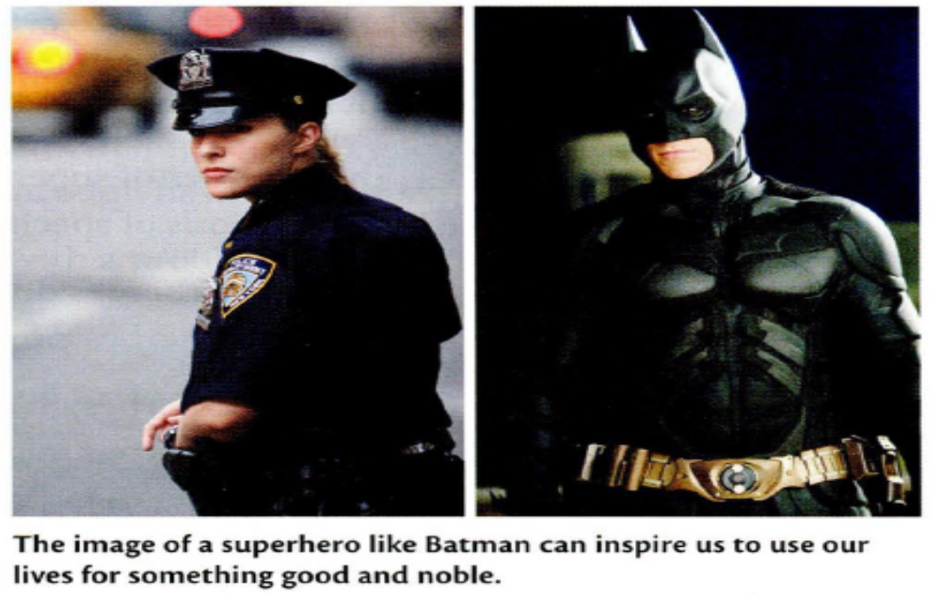

- ______________________________________________________________________________________

2.____________________________________________________________________________________

B. Skim through the excerpt and read the subheadings. Then look at the pairs of sentences below. Check (J') one idea in each pair that you think might be developed in the text.

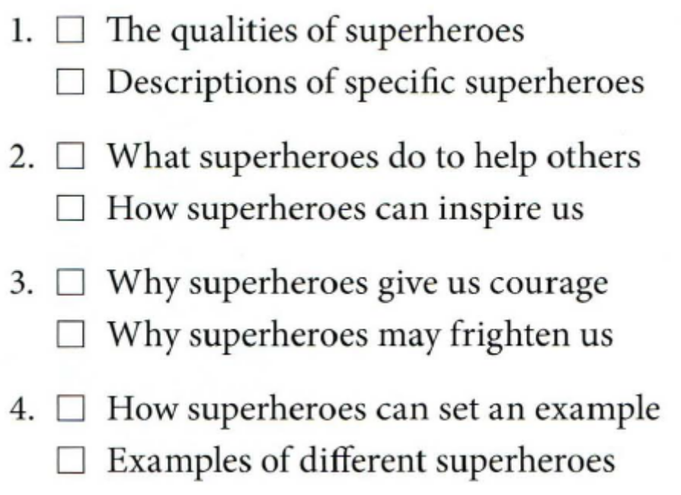

Read the excerpt and confirm your predictions.
We All Need a Hero
1.Many writers, artists, and other people who create the stories of superheroes believe that these characters embody our deepest hopes and fears. They feel that superheroes represent our highest ambitions and help us deal with our worst nightmares. Superheroes face questions we will all have to face in the future, and they shed new light on our present condition. In addition, they do all this in a way that gives us a new sense of direction and resolve in our own lives.

Defining a Superhero
2 Let's start with a simple question. What is a superhero? What sets a superhero apart from a normal person? Well, first of all, they tend to look a bit different. Some wear capes . . . Some of them have cool gadgets ... They wear a lot of tight clothes ... As a rule, superheroes have powers and abilities far beyond ordinary human abilities. But most importantly, every one of them pursues justice, helps people who cannot help themselves, and fights evil with the force of good.

3 Superheroes are extraordinarily powerful people who have both strengths and weaknesses. They typically have superpowers-the ability to fly or to leap over tall buildings-or at least normal human abilities that they have developed to a superhuman level. But while the "super" parts are certainly impressive, we can never forget the "hero" element as well. There are limits to how writers and artists may portray them. A superhero must possess a noble character that guides him or her into worthy achievements. Superheroes may have dark thoughts, just like any human being, but that darkness must be constrained by their desire to do the right thing or the story is not superheroic. So, not every costumed crime fighter is necessarily a hero, and not every character that has superpowers is necessarily a superhero.

Hope and the Superhero
4 The image of the superhero is both inspirational and aspirational. When they are portrayed well in stories and movies, superheroes present us with something that we can all aspire to. Plato, the Greek philosopher, believed that good is inherently attractive. What is good will pull us in its direction as long as we are not blocked from seeing it and appreciating it. That's why the superheroes in our favorite stories are depicted as moral forces, or forces for what is good and right. From childhood and on into adulthood, superheroes can remind us of the importance of self-discipline, self-sacrifice, and using our lives for something good and noble. They can do this while also entertaining us.

5 Of course, most superhero stories are not written to teach us a lesson. Usually, they're just for fun. But they have probably been around for so long and have continued to be so popular, in part because they speak to our hopes. We all aspire to make a difference, to have a positive impact on the world, and to be acknowledged for that impact. Superheroes can keep that flame alive in our hearts when we read about their missions. But their stories also speak to our fears in equally important ways.

Fear and the Superhero
6 We all fear harm. That's just part of being human. In addition, we are often fascinated and worried about the unknown future. By portraying the many different kinds of harm that can enter our lives, superhero stories address those fears. Superheroes display the power of character and courage over adversity, and so they show us that we can also confront and overcome all these dangers and fears.

7 When we confront adversity in our lives, we are often inclined to just give up and find an easier path. But superheroes show us that nothing worth doing is easy. They don't accept defeat, and they won't ever give up. They believe in themselves and their causes, and they go all out to achieve their goals. By showing us that even very powerful people have to fight and struggle, they help us deal with the fears that we all face. So, it will be tough. So what? We can do it.

The Example of the Superhero
8 Superheroes are obviously very gifted individuals. This is true of Superman and many others. But all of us are gifted in some way. All of us have unique talents and powers. If we can follow the superhero's example, we can find the courage to develop and use those gifts in our lives, despite any challenges.

9 Superheroes are moral examples. Superman can inspire us. Batman can keep us going even when the going is very tough. Spider Man can show us the importance of listening to our conscience rather than the voices around us. Daredevil can remind us that our limitations do not need to hold us back, and that we all have hidden strengths.

10 The heroic path is sometimes lonely, but it is always right. If we keep an image of the superheroes in mind-their strength, courage, and resolve-we may find it easier to stay true to that path in the end. What would Superman do? Go do your version of it. The world always needs one more hero.

Here are some words from Reading 1. Read the sentences. Then write each bold word or phrase next to the correct definition.

1. Heroes are people who embody the best human qualities.
2. Superheroes succeed because they have the resolve to keep fighting even when a situation seems
hopeless.
3. I will pursue my goal to be an engineer even though it will be difficult.
4. Winning the competition was an incredible achievement for such a young player.
5. When you set goals, don't be constrained by your present situation. If you can dream it, you can do it.
6. The actor has not been in a movie for ten years, but he still aspires to stardom.
7. Skydiving is an inherently dangerous sport.
8. We all want to be acknowledged for our good deeds and the things we do to help others.
9. He had a hard life, but the adversity and challenges he faced made him a stronger person.
10. She had to confront the problem even though she was frightened.
11. I prefer my usual routine and am not inclined to try new things.
12. The first witness's version of the accident was quite different from the second witness's version.

a ___________ (adj. + prep.) recognized or shown appreciation for something
b. __________ (n .) a strong determination to do something
c. ___________ (adv.) being a basic part of something that cannot be removed
d. ___________ (v. + prep.) to have a strong desire to do or become something
e. ____________(adj.) limited by something or someone
f. ___________ (n.) a difficult or unpleasant situation
g. ___________ (n.) something that has been done successfully, especially through hard work or skill
h. _________(v.) to deal with a problem or difficult situation
i. embody (v.) to represent an idea or quality .
j___________ (adj.) wanting to do something
k. ___________ (n.) a form of something that is different from another form of the same thing
l. ____________ (v.) to try to achieve something over a period of time

Identifying Author’s Purpose:
An author writes with one of four general purposes in mind:

1. To relate a story or to recount events, an author uses narrative writing.
2. To tell what something looks like, sounds like, or feels like, the author uses descriptive writing
3. To convince a reader to believe an idea or to take a course of action, the author uses persuasive
writing.
4. To inform or teach the reader, the author uses expository writing.
Lab Task, Week 1:
Read each paragraph. Then select the answer that best describes the author’s purpose in writing.
The word is terracide. It is not committed with guns and knives, but with relentless bulldozers, roaring dump trucks, and giant shovels like mythological beasts. Dynamite cuts and rips apart mountains to reach the minerals inside, leaving nothing but empty, naked hills. The land is left wasted and allowed to slide down upon houses and into streams, making the land unlivable and the stream water undrinkable. This is terracide, or if you prefer, strip mining.

1. The author’s purpose is to:
a. inform you about the purposes of strip mining.
b. describe a strip mining operation.
c. persuade you that strip mining is bad for the environment.
d. define terracide.
To make a delicious New England pit, proceed as follows: take some water and flour; then construct a bullet-proof dough. Make this into a disk-shaped object. Dry it for a couple of days in a mild temperature. Pour on stewed dried apples and slabs of citron; leave it in a safe place until it petrifies. Serve cold at breakfast and invite your mother-in-law.

2. The author’s purpose is to:
a. tell the steps in making a pie.
b. make fun of (satirize) New England cooking.
c. persuade the reader to buy New England pie.
d. describe New England pie.

I will try to give the reader of this article some idea of the real nature of Gothic architecture, not just of Venice, but of universal Gothic. One of the most interesting parts of our study will be to find out how far Venetian architecture went in achieving the perfect type of Gothic, and how far it fell short of it.

3. The author’s purpose is to:
a. explain the importance of Gothic architecture.
b. describe Venetian architecture.
c. show how Venetian architecture is different from Gothic architecture.
d. show the nature of Gothic architecture.
On September 23, a large cavalry troop from Fort Robinson arrived at the camp of Sitting Bull. Just as he was about to give a welcoming speech, a commotion broke out among the watching warriors. Rifles were fired, and the meeting ended in a massacre of the soldiers.

4. The author’s purpose is to
a. describe Sitting Bull’s camp.
b. persuade the reader that the Indians were bloodthirsty.
c. tell the events leading to a massacre.
d. explain the problems of the Calvary.

Tofu is a product that is becoming very popular as a low-calorie, cholesterol-free meat substitute. Formerly it was found exclusively in Oriental markets and health food stores, but today tofu can be purchased in most supermarket produce departments. This white, cheese like substance is made from the condensed milk of soybeans. It is extremely high in protein and low in sodium. Tofu is almost tasteless by itself, but it can be easily mixed into sauces and soups; it can even be made to imitate scrambled eggs.

5. The author’s primary purpose is to
a. evaluate Oriental cooking.
b. persuade you to eat low-cholesterol foods.
c. describe tofu.
d. to compare tofu with meat.

Our criminal justice system today is a disgrace. Modern day criminals have more rights than an honest citizen ever imagined were written into our U.S. Constitution. Murderers and rapists are typically set free on legal technicalities and seldom face any jail time. While that scum is back to work finding new victims, the pleas of those they have killed, maimed, or violated go unheard. Until we begin giving some real consideration to people who obey the law, instead of those who break it, things are going to continue getting worse.

6. The author’s purpose is to
a. describe the actions of the criminals.
b. compare criminals with honest citizens.
c. inform the reader about the extent of crime in America.
d. criticize our criminal justice system.

Class Task, Week 2:
Identifying Main Idea (Stated) and the Supporting details (major & Minor)
Read the passage on page 3-4 and then read the sentences given below. Number the main ideas in the order they are developed in the excerpt. (Use the subheadings in the excerpt to help you.)

__ a. By confronting dangers and adversity, superheroes teach us to face our fears and never give
up.
__ b. The example of the superhero leads us to develop our own talents and find strength in
ourselves.
1 c. A superhero is a powerful being with abilities beyond ordinary humans and the desire help
others and fight evil.
__ d. The image of the superhero is entertaining, but it also inspires us to use our lives for
something good.
__ e. A character that has superpowers is not necessarily a superhero. The character must also
have the desire to do the right thing.

Now answer the following questions for details:
- What do superheroes represent and help us deal with according to the writers and artists who create them?
________________________________________________________________________________________________________________________________________________________________________________________________________________________

- Do all superheroes have superpowers? If not, what powers do they have?
________________________________________________________________________________________________________________________________________________________________________________________________________________________

- What did Plato believe about "good"?
________________________________________________________________________________________________________________________________________________________________________________________________________________________

- Why have superhero stories been popular for so long?
________________________________________________________________________________________________________________________________________________________________________________________________________________________

- What are we inclined to do when we face adversity?
________________________________________________________________________________________________________________________________________________________________________________________________________________________

- What specific lesson can the character Batman teach us?
________________________________________________________________________________________________________________________________________________________________________________________________________________________

Lab Task, Week 2:
Main Ideas, Topics, and Supporting Details
Identify the following sentences as Main Idea (MI), Topic (T), Supporting Detail (SD):
1. _____ Kinds of power.
2. ____ Influence, the ability to control or affect the behavior of others, is also a form of power.
3. ___ Force, which the Italian statesman Machiavelli called “the method of beasts,” is the use of
physical coercion.
4. ___ Power, the ability to control or change the behavior of others, takes different forms.

Write the sentence number the corresponds with the Topic, Main Idea, Major Detail(s), and Minor Detail(s):
- Functional illiteracy – the inability to read and write well enough to carry out everyday activities – is a complex social problem that stems from several sources.
- One source of the problem is our educational system.
- Our schools are too quick to pass children from one grade to the next even when their learning is woefully deficient.
- Even teachers who care may not want to “buck the system” by refusing to pass along students who have not yet learned important basic skills.
- The community also contributes to functional illiteracy.
- Local businesses and agencies, indifferent to education, do not work with schools towards improving children’s motivation and learning.
- Another source is the home.
- Millions of children grow up with illiterate parents who do not give them the opportunity or encouragement to learn language skills.
- In all too many homes, a television is turned on much of the time, but there are few if any books to interest children in reading.

Pattern of Organization: _________________________________________________________
Main Idea: ____________________________________________________________________
Major Detail: __________________________________________________________________
Minor Detail(s): ___________________________________________________________
Major Detail: _____________________________________________________________
Minor Detail(s): ___________________________________________________________
Major Detail: _____________________________________________________________
Minor Detail(s): ___________________________________________________________
Identify the following as inform (i), persuade(p), or entertain(e).

- _____ Professional athletes do not deserve their inflated salaries, nor does their behavior
merit so much media attention.
2. _____ It’s easy to quit smoking; I’ve done it hundreds of times.
3. _____ On average, women dream more than men, and children dream more than adults.
4. _____ More women should get involved in local politics and support the growing number
of female candidates for public office.

Identifying Author’s Tone:
o Examples of Tone words: accepting, cheerful, admiring, affectionate, alarmed, amused, cruel, disapproving, doubtful, determined, loving, joyous, serious, fearful, humorous, sarcastic, warm, worried, optimistic, solemn, tolerant, hypocritical, ambivalent

- Bitter B. Humorous C. Optimistic D. Sentimental E. Tolerant

- __________________ This place may be shabby, but since both of my children were born
while we lived here, it has a special place in my heart.
- __________________ If only there were some decent jobs out there, I wouldn’t be reduced
to living in this miserable dump.
- __________________ This isn’t the greatest apartment in the world, but it’s not really that
bad.

Highlight and annotate the following paragraph:

1. Highlight in one color (or circle) the main idea of the paragraph.
2. Highlight in another color (or underline) the key details.
3. Write a brief note in the margin to summarize the paragraph.
4. Write a note in the margin that identifies a specific example.

Store windows today must be quick reads. They must be simple enough so that the products can be clearly identified, and they must be creative enough to catch the busy pedestrian’s eye. Just a brief look at a store window should answer many questions for savvy shoppers:-Who is the core market of the store? Does the store fit their personal style or not? How long will a typical trip into
the store take? Especially since today's retail market is so competitive, if done right, windows can function as an important brand-identity tool. As retailers, you must know who your customers are, and you must create windows that they will understand. For instance, Kiehl's, which sells all-natural bath and body products, uses its windows as a place for highlighting social issues, which fits with the priorities of its customers.

Write your ideas.

_______________________________________________________________________________________________________________________________________________________________________________________________________________________________________________________________________________________________________________________________________________________________________________________________________________________________________________________________________________________________________________________________________________________________________________________________________________________________________________________________________________________________________________________________________________________________________________________________________________________________________________________________________________________________________________________________________________________________________

Class Task, Week 3:
Making inferences:
Writers don't usually state all their ideas directly. Usually, they expect the reader to infer some ideas that the information suggests. Making inferences about a text means that you use your knowledge to make a logical conclusion about the information that is given. Look at this excerpt:

The 4-H Study has found that teens from any background can thrive. It doesn't matter if they are rich or poor, from the city or the country, living in a highcrime area, or a low-crime area- anyone can do well with a little help. In order to make these claims, the study had to do the right kind of research.
So you can infer:

1. The study chose to research teens from many backgrounds.
2. The study also looked at the kind of help those teens received in order to be successful.

Making inferences helps you improve your comprehension and understand a text more deeply.

Read the paragraph. Check (.I) the statements that can be inferred from the text. Then compare your answers with a partner. Explain what information in the paragraph led to the inference.

Eliza Parks is a high school senior. She plays two sports, is president of the senior class, and sings in the choir. As a junior, she received her school's top prizes in English and history, and was selected to represent the school at a statewide speech contest. Not surprisingly, Eliza has been accepted at Yale University next year, where she has been awarded a scholarship. Even with all her extracurricular activities and academic commitments, Eliza makes time to be with her brother and her parents. Whenever possible, they eat dinner as a family, and often take trips together on weekends. Eliza also has a strong network of friends who her parents know well. "I talk with my parents very freely about my friends, my life, whatever," she says.

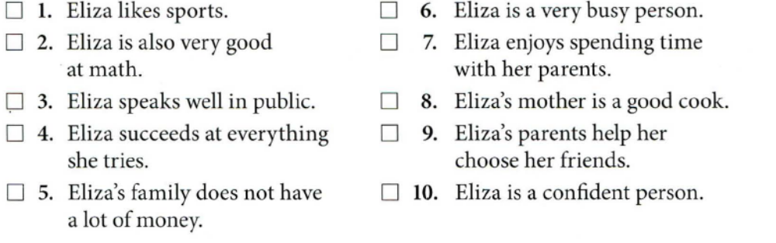

B. Read the paragraph. Circle the answer(s) to each question. You may circle Q, b, or both. Then compare your answers with a partner. Explain your answers.

I have always had to struggle to get out of bed in the morning. When I was a young child, the problem wasn't so bad. Because I didn't want to miss anything that my older siblings were doing, I made myself get up. But as each one of them went away to the college, I had less and less enthusiasm to get up in the mornings. After they were all gone, my father used to come to my bedroom door, knock, and say, " It's 6:00. Wake up and get out of bed." I would respond, "One or the other, Dad. One or the other."

1. What can you infer about the writer?
a. The writer is an adult.
b. The writer is male.

2. What can you infer about the writer's family?
a. The writer had four older Siblings.
b. The writer was the youngest child.

3. What can you infer about the writer's problem?
a. The writer still struggles to get out of bed.
b. It was easier to get out of bed as a child than as a teenager.

4. What can you infer about the writer's father?
a. He used to get up early.
b. He was annoyed because the writer wouldn't get up.

5. What can you infer from the writer's response to the father?
a. The writer has a good sense of humor.
b. The writer would get up right away.

Lab Task, Week 3:
You are going to read an excerpt from author Anne Lamott's memoir, Bird by Bird: Some Instructions on Writing and Life. In it, she looks back at her childhood and the influence that her father had on her.

Bird by Bird
- Every morning, no matter how late he had been up, my father rose at 5:30, went to his study, wrote for a couple of hours, made us all breakfast, read the paper with my mother, and then went back to work for the rest of the morning. Many years passed before I realized that he did this by choice, for a living, and that he was not unemployed or mentally ill. I wanted him to have a regular job where he put on a necktie and went off somewhere with the other fathers and sat in a little office .... But the idea of spending entire days in someone else's office doing someone else's work did not suit my father's soul. I think it would have killed him. He did end up dying rather early, in his midfifties, but at least he had lived on his own terms.

- So I grew up around this man who sat at his desk in the study all day and wrote books and articles about the places and people he had seen and known. He read a lot of poetry. Sometimes he traveled. He could go anyplace he wanted with a sense of purpose. One of the gifts of being a writer is that it gives you an excuse to do things, to go places and explore. Another is that writing motivates you to look closely at life, at life as it lurches bi and tramps around.

- Writing taught my father to pay attention; my father in turn taught other people to pay attention and then to write down their thoughts and observations. His students were the prisoners at San Quentin3 who took part in the creative-writing program. But he taught me, too, mostly by example. He taught the prisoners and me to put a little bit down on paper every day, and to read all the great books and plays we could get our hands on. He taught us to read poetry. He taught us to be bold and original and to let ourselves make mistakes .... But while he helped the prisoners and me to discover that we had a lot of feelings and observations and memories and dreams and opinions we wanted to share, we all ended up just the tiniest bit resentful when we found the one fly in the ointment: that at some point we had to actually sit down and write.

- I believe writing was easier for me than for the prisoners because I was still a child. But I always found it hard. I started writing when I was seven or eight. I was very shy and strange-looking, loved reading above everything else, weighed about forty pounds at the time, and was so tense that I walked around with my shoulders up to my ears, like Richard Nixon• I saw a home movie once of a birthday party I went to in the first grade, with all these cute little boys and girls playing together like puppies, and all of a sudden I scuttled across the screen like Prufrock's crab• I was very clearly the one who was going to grow up to ... keep dozens and dozens of cats. Instead, I got funny. I got funny because boys, older boys I didn't even know, would ride by on their bicycles and taunt me about my weird looks .... I think this is why I walked like Nixon: I think I was trying to plug my ears with my shoulders, but they wouldn't quite reach. So first I got funny and then I started to write, although I did not always write funny things.

- I started writing a lot in high school: journals, impassioned antiwar pieces, parodies of the writers I loved. And I began to notice something important. The other kids always wanted 'me to tell them stories of what had happened, even-or especially-when they had been there. Parties that got away from us, blowups7 in the classroom or on the school yard, scenes involving their parents that we had witnessed-I could make the story happen. I could make it vivid and funny, and even exaggerate some of it so that the event became almost mythical, and the people involved seemed larger, and there was a sense of larger significance, of meaning.

- I'm sure my father was the person on whom his friends relied to tell their stories, in school and college. I know for sure that he was later, in the town where he was raising his children. He could take major events or small episodes from daily life and shade or exaggerate things in such a way as to capture their shape and substance, capture what life felt like in the society in which he and his friends lived and worked .... people looked to him to put into words what was going on.

- I suspect that he was a child who thought differently than his peers, who may have had serious conversations with grown-ups, who as a young person, like me, accepted being alone quite a lot. I think that this sort of person often becomes either a writer or a career criminal. Throughout my childhood I believed that what I thought about was different from what other kids thought about. It was not necessarily more profound, but there was a struggle going on inside me to find some sort of creative or spiritual or aesthetic way of seeing the world and organizing it in my head. I read more than other kids; I luxuriated in books. Books were my refuge. I sat in corners with my little finger hooked over my bottom lip, reading, in a trances, lost in the places and time to which books took me. And there was a moment during my junior year in high school when I began to believe that I could do what other writers were doing. I came to believe that I might be able to put a pencil in my hand and make something special happen.

Then I wrote some terrible, terrible stories.

Read the sentences. Then number the main ideas of the paragraphs in the
correct order (1-7). .
__ a. Her father taught his students how write: to write a little bit every day, to read great books, and not
to be afraid of making mistakes.
__ b. Writing gave her father a reason to explore new things and motivated him to look at life closely.
_ c. In high school, she discovered that her classmates really liked stories about things that had
happened to them-especially if she exaggerated the stories.
_ d. Because she had a different way of thinking about things, she started to believe that she could be a
writer.
__ e. Her father made the choice to work at home and be a writer.
__ f. Because she was nervous and shy, she learned to be funny and started writing.
_ _ g. Her father could take events from everyday life and write about them in a way that expressed the
atmosphere or feeling of the time.

Find these sentences in the excerpt. What can you infer from each sentence? Circle the best answer.

1. Paragraph 1: "I wanted him to have a regular job where he put on a necktie and went off somewhere with the other fathers and sat in a little office:'
a. The author wanted her father to spend more time out of the house.
b. The author wanted her father to have a more "normal" job.

2. Paragraph 2: "Sometimes he traveled. He could go anyplace he wanted with a sense of purpose."
a. When he traveled, he was thinking about how he could write about it.
b. Because he worked at home, his schedule allowed him time to travel a lot.

3. Paragraph 3: " ... we all ended up just the tiniest bit resentful when we found the one fly in the ointment: that at some point we had to actually sit down and write."
a. The author thinks that her father gave them too many writing assignments.
b. The author thinks that writing down your ideas is difficult.

4. Paragraph 4: "I was very clearly the one who was going to grow up to ... keep dozens and dozens of cats."
a. Animals were also important to the author when she was a child.
b. The author had trouble relating to other children.

5. Paragraph 7: "I suspect that he was a child who thought differently than his peers, who may have had serious conversations with grown-ups, who as a young person, like me, accepted being alone quite a lot."
a. The author thinks that she and her father were very similar as children.
b. The author thinks her father should have been more outgoing as a child.

Class Task, Week 4:

Identifying Literary Devices
Read the following excerpts and identify the literary devices (humor, irony, satire) used in them:
- Jane Austen’s novel Pride and Prejudice is one of her most popular works. She presents a very hilarious scene between Mr. and Mrs. Bennet. Mrs. Bennet endlessly breaks down and makes complaints for her husband’s lack of understanding her nerves, and then he responds by saying:
“You mistake me, my dear. I have a high respect for your nerves. They are my
old friends. I have heard you mention them with consideration these twenty years at least.”
- Coming home to a big mess and saying, “it’s great to be back”
- A fire station that burns down
- It is reported that Lady Nancy Astor once said to Winston Churchill that if he were her husband, she would poison his tea. In response, Churchill allegedly said, “Madam, if I were your husband, I’d drink it.”
- Sweden’s Icehotel, built of snow and ice, contains fire alarms.
- Leaving a car wash at the beginning of a downpour
- “I have been assured by a very knowing American of my acquaintance in London, that a young healthy child well nursed is at a year old a most delicious, nourishing, and wholesome food, whether stewed, roasted, baked, or boiled; and I make no doubt that it will equally serve in a fricassee or a ragout”. ( A Modest Proposal by Jonathan Swift)
- Hippopotomonstrosesquippedaliophobia is the official name for fear of long words
- Going on a blind date with someone who is visually impaired
- Kurt Vonnegut’s Breakfast for Champions: “Vietnam was a country where America was trying to make people stop being communists by dropping things on them from airplanes”.
- A Midsummer Night’s Dream (William Shakespeare):
“Ay me! for aught that I could ever read,
Could ever hear by tale or history,
The course of true love never did run smooth”
- George H.W. Bush reportedly stated, “I have opinions of my own, strong opinions, but I don’t always agree with them.”
- Unfortunate Coincidence (Dorothy Parker):
“By the time you swear you’re his,
Shivering and sighing,
And he vows his passion is
Infinite, undying – –
Lady, make a note of this:”
One of you is lying.

Lab Task, Week 4:

Identify Tone in Writings as:
Cheerful, Dry, Assertive, Lighthearted, Regretful, Humorous, Pessimistic, Nostalgic, Melancholic, Encouraging, Facetious, Joyful, Sarcastic, Curious, Arrogant, Persuasive, Uneasy, Regretful, Surprised, Reverent, Inspirational, Formal, Informal etc.

- ____________“The committee will not vote on the matter”
- ____________ “The answer is no, and I don't want to hear another word about it for as long as we both live.”
- ____________ “Nah—I’ve got tons of time to do my chores”
- ____________Rolling her eyes, Emma responded to the bully, ‘Okay, whatever you say goes,' and then forcefully walked away.”
- ____________ “. . . David said with a reassuring smile”
- ____________Knock-knock, who's there? Nobel. Nobel who? No bell, that's why I knocked on the door.”
- ____________ “rocked back and forth, looking out of the window every second. . .”
- ____________ “As she spoke, her conviction was unshakeable and those listening felt moved to join the committee and make changes in their community.”
- ____________ “Esther gave me a cheerful thumbs up from behind the curtain”
- ____________Tillie had a list of questions in her brain, hungry to uncover the truth. . .”
- ____________ “Daniel said with undeniable conviction that commanded the room. . .”
- ____________“I remembered mom’s advice to take a deep breath and jump in. . .”
- ____________ “He opened the door and his eyes widened upon seeing me. . .”
- ____________Go ahead, make my day.” Sudden Impact
- ____________ “That is so fetch.” Mean Girls
- ____________ “May the Force be with you.” Star Wars
- ____________ “Just keep swimming.” Finding Nemo
- ____________ “I still believe in heroes.” Avengers
- ____________ “There’s no place like home.” The Wizard of Oz
- ____________ “You can’t handle the truth!” A Few Good Men
- ____________ “I’m the king of the world!” Titanic
- ____________ “To infinity and beyond!” Toy Story
- ____________ “What’s the most you ever lost on a coin toss?” No Country for Old Men
- ____________A child will make two dishes at an entertainment for friends; and when the family dines alone, the fore or hind quarter will make a reasonable dish, and seasoned with a little pepper or salt will be very good boiled on the fourth day, especially in winter.
- ____________We are travelers on a cosmic journey, stardust, swirling and dancing in the eddies and whirlpools of infinity. Life is eternal. We have stopped for a moment to encounter each other, to meet, to love, to share. This is a precious moment. It is a little parenthesis in eternity.
- ____________ “I’m so glad that jerk was fired; now I won’t have to deal with him anymore.” Vs. “It’s terrible that Tony was let go; he was such a great colleague!”
- ____________ “The movie was amazing! I was laughing so hard I cried!” Vs. “You can only watch infantile humor for so long before you want to punch yourself in the face.”
- ____________ “The principal just called to say that our son was in a fight. I can’t believe he would do that.” Vs. “I’m proud of Billy for sticking up for himself. That bully had it coming.”
- ____________ “I’m so excited that he called! I’ve been hoping to hear from him.” Vs. “Why is that weirdo calling me again after all this time?”
- ____________Having thus lost his understanding, he unluckily stumbled upon the oddest fancy that ever entered into a madman’s brain; for now he thought it convenient and necessary, as well for the increase of his own honor, as the service of the public, to turn knight-errant.
- ____________Neighbors bring food with death and flowers with sickness and little things in between. Boo was our neighbor. He gave us two soap dolls, a broken watch and chain, a pair of good-luck pennies, and our lives. But neighbors give in return. We never put back into the tree what we took out of it: we had given him nothing, and it made me sad.

Class & Lab Task, Week 5:
Rhetorical Patterns and Organization Strategies

Read the following paragraphs using various rhetorical patterns of organization and answer the questions under each paragraph.
Because toys have become electronic devices, some children today are unable to entertain themselves. Gone are the days when children invented their own adventures and used sticks as swords, cookie sheets as armor, and refrigerator boxes as fortresses to defend. The electronic age has delivered children all sorts of gadgets and gizmos that stifle a child’s creativity during play because of pre imagined and limited functions and uses.—some modern toys even have buttons to activate recorded messages of scripted, monotonous .“adventures.” that leave no room for a child to fill in the details. Something has been lost amidst the advent of modern technology: the precious and priceless ability of a child to transform any old object by the simple power of imagination. With no imagination, it is no wonder some children today have short attention spans.

- What are the causes (reasons) the writer presents?
________________________________________________________________________________________________________________________________________________________________________________________________________________________
________________________________________________________________________________________________________________________________________________

- What are the effects (results/consequences)?
________________________________________________________________________________________________________________________________________________________________________________________________________________________
________________________________________________________________________________________________________________________________________________
Compare & Contrast Order: Block Style:

As a child, I thought my parents were ignorant and out of touch with reality. They couldn’t possible understand anything I thought or felt. When they weren’t annoying me with their ridiculous lectures, or grounding me for minor infractions of the rules, they were embarrassing me in public. Now, as a parent myself, I find it frustrating that my children think I have no clue about their lives, even though I understand perfectly well what they are thinking or feeling. I find myself giving my children the same lectures I once thought were ridiculous. My children cannot seem to follow the rules their father and I have set, and they are continuously embarrassing me in public. My, how things have changed.

- What quality is being compared in this paragraph?
________________________________________________________________________________________________________________________________________________________________________________________________________________________

- Who is the writer comparing in this paragraph?
________________________________________________________________________________________________________________________________________________________________________________________________________________________

Compare & Contrast Order: Point by Point Style:

Although they are sisters, Jennifer and Jessica are complete opposites. Jennifer enjoys playing sports while Jessica would rather watch. Jennifer has no interest in playing a musical instrument, but Jessica is the first chair violinist. Jennifer listens to new age music; Jessica prefers country music. Jennifer’s favorite subject is English; conversely, Jessica’s favorite is math. Jennifer likes to curl up in a chair on a rainy day and read a good book while Jessica would rather sleep all day. No one would ever guess that they are actually twins.

- Who are the two people being compared in this paragraph?
________________________________________________________________________________________________________________________________________________________________________________________________________________________

- What are the “points” of comparison between the two subjects?
________________________________________________________________________________________________________________________________________________________________________________________________________________________

Refutation (Opposing Arguments) Order:

[The topic here is Reiki, a natural method of healing in which healers claim to transfer healing energy, called ki, through the palms of the hands.] Opponents of alternative healing methods such as Reiki claim that serious illnesses such as HIV/AIDS and cancer cannot be treated without drugs. Opponents think so because HIV/AIDS and cancer patients often spend the rest of their lives in the hospital taking medicine. However, it is actually common knowledge that, except for cases in which the cancer is diagnosed at an early stage, drugs also cannot treat AIDS or cancer; instead, drugs can only ease pain and suffering caused by other treatments patients must undergo such as chemotherapy. Instead of drugs, which are expensive and have many side effects, an individual can use his/her energy to overcome the hardships of life, find emotional balance, leave the stress of his/her illness and everyday life, and let go of the haunting worries. Most chronic conditions such as eczema or migraines are known to be caused by things like poor diet and stress, and deep rooted anger and other strong emotions can contribute to viral infections. Since balancing our emotions and controlling our thoughts are very important for our overall well being, we should consider that Reiki can help us avoid illnesses and improve our lives in areas that traditional medicines cannot.

1. What is the writer arguing for in this paragraph? What is he/she arguing against (the counterargument)?
________________________________________________________________________________________________________________________________________________________________________________________________________________________

2.How would you describe the writer’s presentation of both views on the topic? (Angrily, incompletely, fair, etc.?)
________________________________________________________________________________________________________________________________________________________________________________________________________________________

(Extended) Definition Order:
I’m a teacher, but not in the traditional sense of the word. T E A C H E R: the word no longer feels as awkward rolling off my tongue and flowing from my fingertips as it once did. A fellow teacher and friend remarked one day during my first semester teaching that she didn’t feel old or smart enough to be a “real” teacher. I still think of this at times and remember how I used to worry that my students would discover my deepest, darkest secret: that I really wasn’t all that old or smart, I didn’t have all the answers, I was still trying to just figure all this writing stuff out too, I was no “expert,” and, really, I simply loved language and to write. Slowly but happily, I discovered this was all it took to be a teacher. Truly loving and always wanting to know more about a subject are the only important qualifications a teacher needs in relation to her subject. Labels like expert, scholar, authority, and even more playful ones like guru or champion are grossly inept because they all suggest that a person can somehow achieve, overcome, or conquer knowledge. What a preposterous, pretentious notion considering that we’d still be trying to bash open walnuts with rocks and make square wheels turn if our Neanderthal ancestors had one day decided that they had learned all there was to know in the world. There are instead so many more humble, honest, and apt terms that capture what a teacher is and does: adventurer, watcher, dreamer, analyst, risk taker, catalyst, seeker, builder, enthusiast.—to name just a few. I have come to believe that a true teacher cannot ever “master” a subject (and those who think they can are likely the most dreadful bores you.’ve ever had). For authentic, sincere teachers, there is no prize at the end of the race because there is no race in the first place. There is only the energy, motivation, and desire to run, discover, never stop chasing it down.

1.What word or term is the writer redefining in this paragraph?
________________________________________________________________________________________________________________________________________________________________________________________________________________________

2.What is the writer’s new definition of this word/term?
________________________________________________________________________________________________________________________________________________________________________________________________________________________

Order of Importance or Climax: Standard Style (Least to Most):

My encounter with nature became a learning experience for me. I learned to come prepared for anything. Our canoe overturning was proof that anything could happen. All of our supplies were gone. I also learned that although nature is beautiful, she can also be deadly. If it hadn.’t been for the cave we discovered in the moonlight, the hail storm surely would have killed us. Most of all, I learned to trust my mother. I never thought I would say this, but she does know a thing or two. She kept her wits about her and kept me calm as well. Even in the middle of nowhere without any supplies, she still managed to take care of me. Her grandfather had taught her how to survive in the wild, and she hadn.’t forgotten a thing.

- What is the writer ranking (assigning degrees of importance to) in this paragraph?
________________________________________________________________________________________________________________________________________________________________________________________________________________________

2. List the writer.’s ideas in the same order of importance as the writer has presented them.
________________________________________________________________________________________________________________________________________________________________________________________________________________________

Order of Importance or Climax: Reverse Style (Most to Least):

A plan to improve the city.’s park was approved Monday night by the city council. The plan involves adding landscaping to the north end, rebuilding the bridge over the lake, and updating the playground equipment. Funds for the project have been donated by local businesses who hope that improving the park will bring more people to the downtown area which will in turn bring more customers. The next order of business is for the city council to open the bidding process for the various improvements. After bids are accepted by the council, the massive overhaul and construction project that will eventually transform the city.’s downtown area can final begin.

1.What is the writer ranking (assigning degrees of importance to) in this paragraph?
________________________________________________________________________________________________________________________________________________________________________________________________________________________

2.List the writer’s ideas in the same order of importance as the writer has presented them.
________________________________________________________________________________________________________________________________________________________________________________________________________________________

Generalization & Example (Statement & Clarification) Order:

A quick tour through my house will convince you that I am an extremely messy person.—even a slob. Starting in my bedroom, you will see clothes tossed around as if thieves had just looted the place. T shirts dangle from door knobs, socks sit balled up on top of the dresser, and blue jeans cover the floor like a drop cloth. A trail of shoes and sneakers leads you out of the bedroom and into the bathroom. There you will stand on a sopping towel and see a blow dryer and a copy of Newsweek lying on the sink alongside an uncapped tube of Crest. Just behind you is the towel rack: no towel, naturally, just a dripping shirt and a crusty old bathrobe belt. Next to the bathroom is the kitchen.—slob headquarters. To the left are erupting bags of garbage, a bald tire, and a tall stack of yellow newspapers. To the right you'll notice a greasy oven stacked high with pots and—beside it—a sink full of gray water and dirty dishes. Considering all the items you must hop over, step on, and avoid altogether, touring my house is more like completing an obstacle course than a casual stroll from room to room.

1.What is the generalization in this paragraph?
________________________________________________________________________________________________________________________________________________________________________________________________________________________

2. The writer uses a distinct rhetorical strategy to develop this paragraph. What is it?
________________________________________________________________________________________________________________________________________________________________________________________________________________________

Classification (Topical) Order:

There are four basic kinds of writing: each mode may take different forms but has a primary purpose. The first is expository writing, which has a purpose of explaining something or giving directions, such as providing directions to your house. The second mode is persuasive writing, which has a purpose of influencing the reader’s way of thinking. A politician.’s speech is an example of persuasive writing. The third mode is descriptive writing, which has a purpose of providing vivid details so that the reader can picture what is being presented. An essay that depicts the glorious Grand Canyon fits into this category. The fourth mode is narrative writing, which has a purpose of presenting an experience in the form of a story. A personal account of a vacation is an example of narrative writing. Through these four modes, or combinations of modes, writers have several options for expressing their ideas.

1.What categories does the writer break the content of the paragraph into?
________________________________________________________________________________________________________________________________________________________________________________________________________________________

2.Why do you think the writer put the topics in this particular order? What purpose might the writer have for ordering his points this way?
________________________________________________________________________________________________________________________________________________________________________________________________________________________

Chronological (Time) Order:

It seemed like an ordinary day when she got up that morning, but Lynda was about to embark on the worst day of her life. First, she fell in the bathtub because her mother forgot to rinse out the bath oil. Then Lynda spilled orange juice on the outfit she had spent hours putting together for her school pictures. When she changed, she messed up the French braid her mother had put in her hair. She dropped all of her school books as she walked out the door and her math homework flew away in the wind. Once she made it to the car, she thought everything would be all right. She was wrong: her father didn't look before he backed out of the driveway and ran into the neighbor’s truck. Lynda’s side of the car was damaged the most, and she ended up with a broken arm. That night, she cried herself to sleep.

1. Is there a topic sentence in this paragraph? What about a concluding sentence? What’s the main idea?
________________________________________________________________________________________________________________________________________________________________________________________________________________________

2. Are all of the details in the paragraph relevant? Why or why not?
________________________________________________________________________________________________________________________________________________________________________________________________________________________

Problem to Solution Order:

Several students receive poor grades on writing assignments, not because they lack the ability to communicate but because they cannot seem to manage their time when it comes to a large project. They do not know where to begin and therefore put things off until the last minute. To solve this problem, students need to develop a timeline for completing the project. If they divide the assignment into manageable .“chunks.” or parts and then set a schedule for completing each part, they will be able to finish the entire project before the deadline. Without the pressure of not knowing where to begin, the students will be able to focus on the assignment and communicate their ideas effectively.
1.What is the problem presented in the paragraph? What is the solution?
________________________________________________________________________________________________________________________________________________________________________________________________________________________

2.What rhetorical strategy does the writer use to develop his/her idea?
________________________________________________________________________________________________________________________________________________________________________________________________________________________

Spatial Order:

I couldn’t believe my eyes when we finally emerged from the storm shelter. Where the barn once stood there was now only a few tufts of hay, the path that led to the house was scattered with branches and debris, and the entire roof of the house was gone. The north wall was caved in and we could see right into the house.—what was left of it. Tears rolled down my cheeks as I noticed that most of our belongings had been sucked up into the great vacuum and scattered across the countryside. We heard a loud cracking and moaning as the west wall gave way and collapsed, sending up a wave of dust. And yet, there in the middle of the front yard was mother’s prized rose bush, swaying in the breeze as if nothing had happened. Seeing it made me realize how lucky we were to be alive. We stood there in dismay, our arms locked around one another.

1. This is a paragraph without a clear topic sentence. What, then, is the main idea? How do you know?
________________________________________________________________________________________________________________________________________________________________________________________________________________________

2. What rhetorical strategies does the writer use to develop the idea? Name more than one.
________________________________________________________________________________________________________________________________________________________________________________________________________________________

Sequential Order:

The first step in redesigning your closet is to take everything out and sort through it. Anything you haven’t worn in over a year should be given to charity. Check garments for wear and tear and take care of anything that needs mending. If it is beyond repair, get rid of it. The second step is to install a closet organizer. Choose one that will hold the different types of garments in your wardrobe. The third step is to put items in the closet so that those you wear most often are easy to access. The final step is to stay organized. Put garments back in their appropriate places so that you will be able to find them.

1. This is another paragraph without a clear topic sentence. Is there a main idea? What is it? How do you know?
________________________________________________________________________________________________________________________________________________________________________________________________________________________

2. How would you describe the .“flow.” of this paragraph? Is it smooth, easy to read? Why or why not?
________________________________________________________________________________________________________________________________________________________________________________________________________________________

Order of Familiarity:

African Americans know what it is like to be underestimated because of the color of their skin. For example, a black person who communicates with others using in Standard English are often praised unduly for how well they speak. This is also an occurrence too often experienced by Asian Americans as well, including those born and bred in the U.S.A. And black folk know what it is like to be feared, pitied, admired, and scorned simply on account of our race before we even have a chance to “boo!.” We, in turn, view white people through the prism of our own race based expectations. I honestly am surprised every time I see a white man who can play basketball above the rim, just as Puerto Ricans and Cubans tend to be surprised to discover .“Americans.” who salsa truly well. All of which is to say that the notion that every individual is judged solely on personal merit, without regard for sociological wrapping, is mythical at best.

1. What is the main idea of this paragraph? Where is it? How do you know?
________________________________________________________________________________________________________________________________________________________________________________________________________________________

2.What rhetorical strategies does the writer use to develop his/her ideas?
________________________________________________________________________________________________________________________________________________________________________________________________________________________

Read each passage and answer the questions that follow:

A boycott is an organized refusal by people to deal with a person or group in order to reach a certain goal. An example is the famous boycott that began in 1955 when Mrs. Rosa Parks of Montgomery, Alabama, refused to obey a law requiring black people to sit at the back of city buses. Mrs. Parks was arrested, and her arrest sparked a boycott of the city bus system by African Americans. The boycott was organized and led by Dr. Martin Luther King, Jr. Rather than continue to lose money needed to run the bus system, the city changed the law.

- The main pattern of organization is:
- definition and example
- cause and effect
- comparison-contrast
- time order
Transitions that signal the pattern: _________________________________________________

Many people say rapid population growth is the reason why nearly one billion people go hungry every day. However, political factors are also among the causes of hunger. Firs, many countries with hungry citizens actually export crops to other countries. Exporting the crops offers greater profits than selling them at home. Secondly, surpluses that could feed many people are often destroyed in order to keep the price of products high. For example, some crops are allowed to rot, and extra milk is fed to pigs or even dumped.

- The main pattern of organization is:
- definition and example
- cause and effect
- comparison-contrast
- time order
Transitions that signal the pattern: _________________________________________________

The following selections are main ideas taken from different paragraphs in a college textbook. Which pattern of organization does each one most likely suggest?

1. ______________________ Parents tend to treat the oldest child differently from his or her siblings.
2. ______________________ Artificial intelligence (AI) is a term that describes computer programs that solve problems by “thinking” the way people do.
3. ______________________ The high cost of college today creates several problems for many students in more ways than one.
4. ______________________ Identical twins, even when raised separately, have remarkably similar mannerisms.
5. ______________________ The bartender keeps a gun under his cash register, and next to that, a can of Mace.
6. ______________________ Certain colors are associated with particular emotions, as in the following examples.
7. ______________________There are a number of symptoms of drug abuse.
8. ______________________ King Ludwig’s castle had several well-placed towers from which archers could fire on an attacking army.
9. _______________________There are three reasons why Titanic sank.
10. ______________________ The following is a description of the North Shore Music Theater, from the entrance hall to backstage.
11. ______________________ Her behavior was unusual yesterday in a number of ways.
12. ______________________ Usury is the practice of lending money and charging too much for interest.

Class & Lab Task, Week 6:

Organization of texts:

- Explain the following terms in italic:

Shorter texts, e.g. essays, are normally organised in the form:
Introduction > Main Body > Conclusion
Longer texts, e.g. dissertations and articles, may include (depending on subject area):
Abstract > Contents > Introduction > Main Body > Case Study >
Discussion > Findings > Conclusion > Acknowledgements >
Bibliography/References > Appendices
Books may also contain:
Dedication > Foreword > Preface > Index

b) Match the definitions below to one of the terms in (2a).

i) Short summary (100–200 words) of the writer’s purpose and findings (. . . . . . .)
ii) Section where various people who assisted the writer are thanked (. . . . . . .)
iii) Final part where extra data, too detailed for the main text, are stored (. . . . . . .)
iv) List of all the books that the writer has consulted (. . . . . . .)
v) Section looking at a particular example relevant to the main topic (. . . . . . .)
vi) Introductory part of book which may give the writer’s motives (. . . . . . .)
vii) Alphabetical list of all topics in the text (. . . . . . .)
Planning Titles for Paragraphs:
- When preparing to write an essay, it is essential to identify the main requirements of the title. You must be clear about what areas your teacher wants you to cover. This will then determine the organization of the essay. For example:

Academic qualifications are of little practical benefit in the real world – Discuss.
Here the key word is discuss. Discussing involves examining the benefits and drawbacks of something.

Underline the key words in the following titles and consider what they are asking you to do.

a) Define Information Technology (IT) and outline its main applications in medicine.
b) Compare and contrast the appeal process in the legal systems of Britain and the USA.
c) Evaluate the effect of mergers in the motor industry in the last ten years.
d) Trace the development of primary education in Britain. Illustrate some of the issues currently facing this sector.
Note that most of the titles above have two terms in the title. You must decide how much importance to give to each section of the essay (e.g. title (a) might demand 10% for the definition and 90% for the outline).

2. The following terms are also commonly used in essay titles.
Match the terms to the definitions on the right.

Analyse Give a clear and simple account
Describe Make a proposal and support it
Examine Deal with a complex subject by giving the main points
State Divide into sections and discuss each critically
Suggest Give a detailed account
Summarise Look at the various parts and their relationships

Almost all essays, reports and articles have the same basic pattern of
organisation:
Introduction
Main body
Conclusion

The structure of the main body depends on what the title is asking you to do. In the case of a discuss type essay, the main body is often divided into two parts, one looking at the advantages of the topic and the other looking at the disadvantages.

Write a plan for one of the titles in (1).

title

introduction

main body

conclusion
5. Teachers often complain that students write essays that do not answer the question set.
Consider the following titles and decide which sections should be included in each essay.

a) Describe the growth of the European Union since 1975 and suggest its likely form by 2010.
A short account of European history 1900–2000
An analysis of candidates for membership before 2010
A discussion of the current economic situation in Europe
An outline of the enlargement of the EU between 1975 and now

b) Summarize the arguments in favor of privatization and evaluate its record in Britain.
A case study of electricity privatization
An analysis of less successful privatizations
A study of major privatizations in the UK
A discussion of the benefits achieved by privatization

c) To what extent is tuberculosis (TB) a disease of poverty?
A definition of TB
A report on the spread of TB worldwide
A case study showing how TB relates to social class
A discussion of new methods of treating the disease

d) Nursery education is better for children than staying at home with mother – Discuss.
A study of the growth of nurseries since 1995
A report on the development of children who remain at home until five
A discussion comparing speaking ability in the two groups of children
An outline of the increase of women in the labor market since 1960

e) Compare studying in a library with using the internet. Will the former become redundant?
The benefits of using books
The drawbacks of internet sources
Predicted IT developments in the next 15 years
An outline of developments in library services since 1945

6. Underline the key terms in the following titles and decide what you are being asked to do.
Example:
Relate the development of railways to the rise of nineteenth-century European nationalism.
Relate means to link one thing to another. The title is asking for links to be made between the growth of railways in Europe in the nineteenth century and the political philosophy of nationalism. The writer must decide if there was a connection or not.

a) Identify the main causes of rural poverty in China.
b) Calculate the likely change in coffee consumption that would result from a 10% fall in the price of coffee beans.
c) Classify the desert regions of Asia and suggest possible approaches to halting their spread.

Evaluating a Text:

1. When reading a text, it is important to ask yourself questions about the value of the text. Is this text fact or opinion? If fact, is it true? If opinion, do I agree? Can this writer be trusted? These questions can be shown in a diagram:

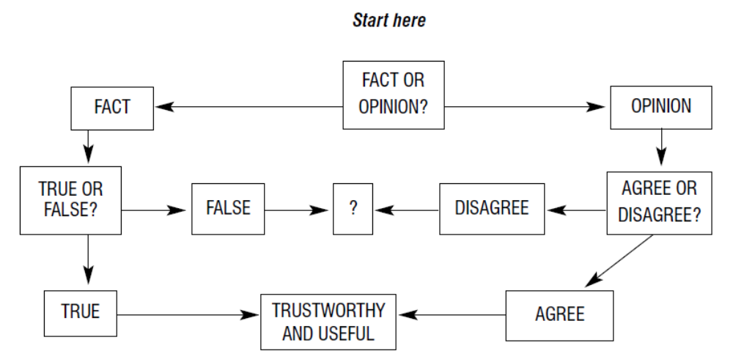
Read the following sentences and decide first if they are fact or opinion. Then decide if the factual sentences are true, and if you agree with the opinions in the other sentences.
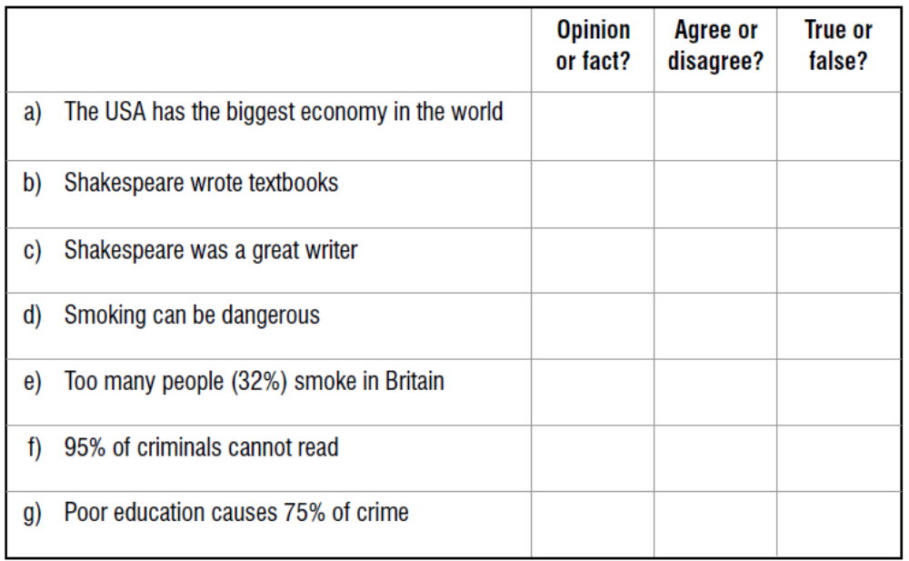

Understanding Purpose and Register:
- Compare the two extracts below:

a) Rebus College is seeking candidates for the position of Treasurer. As the Chief Financial
Officer of the College, the Treasurer is responsible for working with the senior administration and Trustees to develop and implement a financial strategic vision for the College.

b) Are you wondering what to do with that jumper you were given for Christmas that’s two sizes too small – or worse, the personal stereo that simply doesn’t work? Well, don’t worry. Chances are, you’ll be able to get your dud gifts swapped, fixed or get a refund. And, armed with our guide to your rights, you’ll be able to get any defective products sorted.

2. Read the following extracts and complete the table using one or two of the following: inform/amuse/persuade/entertain.

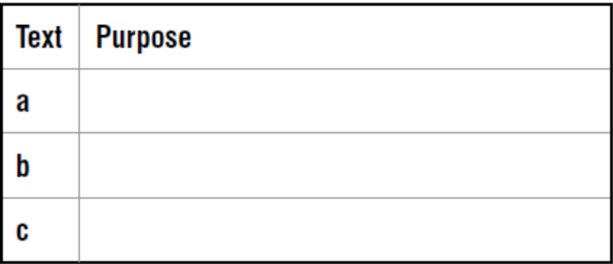

- The lower you are in the office hierarchy, the more disgusting your sandwiches. You can safely assume that a chicken and banana man is not a main board director. Some people, generally those in accounts, have had the same sandwich for the past 30 years. People like to prove how busy they are by eating their sandwich at their desk. But this is counter-productive, because every time you take a mouthful the phone rings, and you’ll only get to finish that last mouthful just before you go home.

- Writing for publication can be both profitable and enjoyable. It’s open to everyone, because you don’t need any qualifications. In Britain there is a huge demand for new materials, with thousands of newspapers and magazines published every week. In addition there are TV and radio programs, the theatre and films. Given this situation, there are many openings for new writers. But the director of one of the UK’s main writing colleges, the Writing Academy, advises: ‘to enter this market successfully you must have good training’.

c) The Advertising Standards Authority makes sure that advertising is legal, decent, honest and truthful. The Authority safeguards the public by ensuring that the rules contained in the British Code of Advertising Practice are followed by everyone who prepares and publishes advertisements in the UK, and that advice is freely available to prevent problems arising. The Code lays down what is and is not acceptable in advertisements, except for those on TV and radio.

Class & Lab Task, Week 7:
Selecting Key Points:
1. The first stage of note-making is to identify the key points in the text for your purpose.
Study the following example (key points in italic).

WHY WOMEN LIVE LONGER

Despite the overall increase in life expectancy in Britain over the past century, women still live significantly longer than men. In fact, in 1900 men could expect to live to 49 and women to 52, a difference of three years, while now the figures are 74 and 79, which shows that the gap has increased to five years. Various reasons have been suggested for this situation , such as the possibility that men may die earlier because they take more risks. But a team of British scientists have recently found a likely answer in the immune system, which protects the body from diseases. The thymus is the organ which produces the T cells which actually combat illnesses. Although both sexes suffer from deterioration of the thymus as they age, women appear to have more T cells in their bodies than men of the same age. It is this, the scientists believe, that gives women better protection from potentially fatal diseases such as influenza and pneumonia.

Having selected these sections of the text, you can then go on to make notes from them:
British women live longer than men: 79/74
reasons? new research suggests immune system > thymus > T cells
women have more T cells than men = better protection

2. Read the following and then choose a suitable title that expresses the key point.

TITLE: . . . . . . . . . . . . . . . . . . . . . . . . .

Dean Kamen is a 50-year-old American eccentric who is also a multi-millionaire. He always wears blue denim shirts and jeans, even when visiting his friend, the president, in the White House. He flies to work by helicopter, which he also uses for visiting his private island off the coast of Connecticut. As an undergraduate Kamen developed the first pump that would give regular doses of medicine to patients. The patent for this and other original medical inventions has produced a huge income, allowing him to run his own research company which, among many other projects, has produced the iBot, the world’s first wheelchair which can climb stairs.

3. In the following text, three key points are in italic. Decide on their order of importance.

HOT RUBBISH

- The majority of people in the small Derbyshire village of Pools brook have joined a scheme to make power from rubbish. b) Methane gas will be collected from the local rubbish tip and will be used to heat houses more cheaply and generate electricity. The villagers, who have been affected by the closure of the local coal mines, suffer from unemployment, so cheap heating is especially important for them. They have raised the £2 million cost from development agencies. c) The new system, which will be the first of its kind in Europe, will lead to a healthier environment by cutting CO2 emissions, and should also create three full-time jobs.

1) . . . . . . . . . . . . . . . . . . . . . . .
2) . . . . . . . . . . . . . . . . . . . . . . .
3) . . . . . . . . . . . . . . . . . . . . . . .

4. Underline four key points in the following text.

THE SIXTH WAVE?

Lord May, the president of the Royal Society, has claimed that the world is facing a wave of extinctions similar to the five mass extinctions of past ages. He calculates that the current rate of extinction is between 100 and 1,000 times faster than the historical average. The cause of previous extinctions, such as the one which killed the dinosaurs, is uncertain, but was probably an external event such as collision with a comet.

However the present situation is caused by human consumption of plants, which has resulted in a steady increase in agriculture and a consequent reduction in habitat for animals. Although many people are still hungry, food production has increased by 100% since 1965.

Lord May also pointed out that it was very difficult to make accurate estimates as nobody knew how many species of animals lived on the planet. So far 1.5 million species had been named, but the true figure might be as high as 100 million. Our ignorance of this made it almost impossible to work out the actual rate of extinction. However, the use of intelligent guesses suggests that losses over the past century were comparable with the extinctions of earlier periods, evidence of which is found in the fossil record.

Note Taking:
1. What are the main reasons for note-making?
Add to the ideas below.
a) to avoid plagiarism
b) …………
c) …………
d) …………

2. Effective note-making is part of a sequence.
What comes before and after?
- You are writing an essay on ‘Conservation at sea’. You find the following article in a magazine called Science South, volume 27 (2002). The author is J. Doyle. Read the text (key points in italic) and make notes.

STUDYING SQUID

Before the British occupation of the Falkland Islands in 1833 most of the sailors who went there were mainly interested in collecting oil and skins from the whales, seals and penguins which flourished in the South Atlantic. The British introduced sheep farming, but since this became less profitable after the 1960s the islanders have been forced to pay more attention to the contents of the island waters.

These waters are rich in squid, and the sale of fishing licenses for this harvest has funded research to allow the stocks to be managed efficiently. There are two kinds of squid around the Falklands; Illex is eaten in East Asia, while Loligo is popular in Spain. The latter was found to breed at two periods in the year; one season is May to July and the other is October and November. This second period, which is summer in the South Atlantic, coincides with the local penguin breeding season and makes the baby squid more vulnerable. As a result, the scientists suggested that the fishing season for Loligo should be postponed for a few months to allow the stock to recover, and when this was done the fishermen found that they had a better catch than before. The other squid, Illex, was found to have a different pattern, swimming south from Brazil to the Falklands in summer, and then back north again. To deal with a species that migrates through the waters of several countries it has been necessary to set up an agreement between the governments concerned to restrict the fishing season in order to allow squid numbers to build up.

Paraphrasing:

1. Although paraphrasing techniques are used in summary writing, paraphrasing does not aim to shorten the length of a text, merely to restate the text.

For example,
Evidence of a lost civilization has been found off the coast of China.
could be paraphrased:
Remains of an ancient society have been discovered in the sea near China.

2. A good paraphrase is significantly different from the wording of the original, without altering the meaning at all.
Read the text below and then decide which is the best paraphrase, (a) or (b).

Ancient Egypt collapsed in about 2180 BC. Studies conducted of the mud from the River Nile showed that at this time the mountainous regions which feed the Nile suffered from a prolonged drought. This would have had a devastating effect on the ability of Egyptian society to feed itself.

a) The sudden ending of Egyptian civilization over 4,000 years ago was probably caused by changes in the weather in the region to the south. Without the regular river flooding there would not have been enough food.

b) Research into deposits of the Egyptian Nile indicate that a long dry period in the mountains at the river’s source may have led to a lack of water for irrigation around 2180BC, which was when the collapse of Egyptian society began.

3. Techniques.

a) Changing vocabulary:
studies > research
society > civilisation
mud > deposits

b) Changing word class:
Egypt (n.) > Egyptian (adj.)
mountainous regions (adj. + n.) > in the mountains (n.)

c) Changing word order:
Ancient Egypt collapsed > the collapse of Egyptian society began

4. Find synonyms for the words in italic.

a) Sleep scientists have found that traditional remedies for insomnia, such as counting sheep, are ineffective.
Example:
Sleep researchers have found that established cures for insomnia, for instance counting sheep,
do not work.

b) Instead, they have found that imagining a pleasant scene is likely to send you to sleep quickly.

c) The research team divided 50 insomnia sufferers into three groups.

d) One group was told to imagine a waterfall, while another group tried sheep counting.

5. Change the word class of the words in italic, and then re-write the sentences.

a) A third group was given no special instructions about going to sleep.
Example:

A third group was not specially instructed about going to sleep.

b) It was found that the group thinking of waterfalls fell asleep 20 minutes quicker.

c) Mechanical tasks like counting sheep are apparently too boring to make people sleepy.

6. Change the word order of the following sentences.

a) There are many practical applications to research into insomnia.
Example:

Research into insomnia has many practical applications.

b) About one in ten people are thought to suffer from severe insomnia.

c) It is calculated that the cost of insomnia for the American economy may be $35 billion a year.

- Combine all these techniques to paraphrase the paragraph as fully as possible.

Sleep scientists have found that traditional remedies for insomnia, such as counting sheep, are ineffective. Instead, they have found that imagining a pleasant scene is likely to send you to sleep quickly. The research team divided 50 insomnia sufferers into three groups. One group imagined watching a waterfall, while another group tried sheep counting. A third group was given no special instructions about going to sleep. It was found that the group thinking of waterfalls fell asleep 20 minutes quicker. Mechanical tasks like counting sheep are apparently too boring to make people sleepy. There are many practical applications for research into insomnia. About one in ten people are thought to suffer from severe insomnia. It is calculated that the cost of insomnia for the American economy may be $35 billion a year.

________________________________________________________________________________________________________________________________________________________________________________________________________________________________________________________________________________________________________________________________________________________________________________________________________________________________________________________________________________________________________________________________________________________________________________________________________________________________________________________________________________________________________________________________________________________________________________________________________________________________________________________________________________________________________________________________________________________________________

Summary Writing:

1. Choose four of the topics below and write summaries in no more than twelve words each.
Example:
Birmingham is a large industrial city in the English West Midlands.
a) Your home town
b) Bill Gates
c) Your academic subject
d) The last book you read
e) A film you saw recently
f) Your mother/father

2. In essay writing students often have to summarize part of a book or journal article.

The summary may be just one or two sentences, to explain the main idea of the article, and perhaps compare it with another summarized text, or it might be necessary to include much more detail. In other words, a summary can range from 1–2% of the original to more than 50%: summarizing is a flexible tool. At first students need to follow a series of steps to summarize successfully. With practice the number of steps may be reduced, as the process becomes more automatic.

Complete the list of stages in a successful summary.
a) Read the text carefully and check key vocabulary.
b) Underline or highlight the . . . . . . . . . . . . . . . . . . . . . . . . . . . . . . . . . . . . . . . . . . . . . . . . . . . . . . . . . . . . . . . .
c) Make notes of these, taking care to . . . . . . . . . . . . . . . . . . . . . . . . . . . . . . . . . . . . . . . . . . . . . . . . . . . .
d) Write the summary using the notes, re-organizing the . . . . . . . . . . . . . . . . . . . . . . . . .
e) Check the summary to make sure no . . . . . . . . . . . . . . . . . . . . . . . . . . . . . . . . . have been omitted or distorted.

4. Read the following text and compare the summaries. Decide which is best, giving reasons.

Researchers in France and the United States have recently reported that baboons are able to think abstractly. It has been known for some time that chimpanzees are capable of abstract thought, but baboons are a more distant relation to mankind. In the experiment, scientists trained two baboons to use a personal computer and a joystick. The animals had to match computer designs which were basically the same but had superficial differences. The baboons performed better than would be expected by chance. The researchers describe their study in an article in the Journal of Experimental Psychology.

a) French and American scientists have shown that baboons have the ability to think in an
abstract way. The animals were taught to use a computer, and then had to select similar patterns, which they did at a rate better than chance.

b) Baboons are a kind of monkey more distant from man than chimpanzees. Although it is
known that chimpanzees are able to think abstractly, until recently it was not clear if baboons could do the same. But new research has shown that this is so.

c) According to a recent article in the Journal of Experimental Psychology, baboons are
able to think in an abstract way. The article describes how researchers trained two baboons to use a personal computer and a joystick. The animals did better than would be expected.

4. Read the following text and underline the key points.

Indian researchers are trying to find out if there is any truth in old sayings which claim to predict the weather. In Gujarat farmers have the choice of planting either peanuts, which are more profitable in wet years, or castor, which does better in drier conditions. The difference depends on the timing of the monsoon rains, which can arrive at any time between the beginning and the middle of June. Farmers, however, have to decide what seeds to sow in April or May.

There is a local saying, at least a thousand years old, which claims that the monsoon starts 45 days after the flowering of a common tree, Cassia fistula. Dr Kanani, an agronomist from Gujarat Agricultural University, has been studying the relationship since 1996, and has found that the tree does successfully predict the approximate date of the monsoon’s arrival.

5. Complete the following notes of the key points.
a) Indian scientists checking ancient . . . . . . . . . . . . . . . . . . . . . . . . . . . . . . . . . . . . . . . . . . . . . . . . . . . . . .
b) Old saying links monsoon to . . . . . . . . . . . . . . . . . . . . . . . . . . . . . . . . . . . . . . . . . . . . . . . . . . . . . . . . . . . . .
c) Used by farmers to select peanuts (for wet) or . . . . . . . . . . . . . . . . . . . . . . . . . . . . . . . . . . . . .
d) Dr Kanani of Gujarat Agricultural University has found that . . . . . . . . . . . . . . . .
. . . . . . . . . . . . . . . . . . . . . . . . . . . . . . . . . . . . . . . . . . . . . . . . . . . . . . . . . . . . . . . . . . . . . . . . . . . . . . . . . . . . . . . . . . . . . . . . . . . . . . . .

Class & Lab Task, Week 8:
Combining Sources:
- Read the example, from a study of women’s experience of prison.

According to Giallombardo (1966), women alleviated the pains of imprisonment by developing kinship links with other inmates. Similarly Heffernan (1972) found that adaptation to prison was facilitated by the creation of a pseudo-family. Owen (1998) also notes that the female subculture is based on personal relationships with other women inmates. Others, however, believe that the subculture in women’s prisons is undergoing a gradual shift that more closely resembles that of male prisons. Fox (1982) states, for example, that the cooperative caring prison community that has embodied characterizations of female prisons has evolved into a more dangerous and competitive climate.

- How many writers are mentioned?
__________________________________________________________________________________________________________________________________________

- What is the function of the words in italics?
__________________________________________________________________________________________________________________________________________

- What phrase is used to mark the point in the text where there is a shift from one point of view to another?
__________________________________________________________________________________________________________________________________________

2. Below are two sources used for an essay titled ‘Should genetically modified (GM) foods have a role in future agriculture?’ Read the sources first, then the essay extract.

SOURCE A
Genetic modification (GM) is the most recent application of biotechnology to food, which can also be called genetic engineering or genetic manipulation. The phrase ‘Genetically Modified Organisms’ or GMOs is used frequently in the scientific literature to describe plants and animals which have had DNA introduced into them by means other than the ‘natural’ process of an egg and a sperm. New species have always evolved through natural selection by means of random genetic variation. Early farmers used this natural variation to selectively breed wild animals, plants and even micro-organisms such as yogurt cultures and yeasts. They produced domesticated variants better suited to the needs of humans, long before the scientific basis for the process was understood. Despite this long history of careful improvement, such procedures are now labelled ‘interfering with nature’.

SOURCE B
Genetic modification (GM) is in fact far more than a mere development of selective breeding techniques. Combining genetic material from species that cannot breed naturally is an interference in areas which may be highly dangerous. The consequences of this kind of manipulation cannot be foreseen. It seems undeniable that these processes may lead to major benefits in food production and the environment. There is no doubt, for example, that some medical advances may have saved
millions of lives. However, this level of technology can contain a strong element of risk. Our ignorance of the long-term effects of releasing GM plants or even animals into the environment means that this step should only be taken after very careful consideration.

ESSAY EXTRACT:
It has been claimed that GM technology is no different from breeding techniques which have been practiced by man for thousands of years. Source A states that this process is similar to natural selection and remarks: ‘such procedures are now labelled “interfering with nature”’. On the other hand Source B considers that, although GM technology could bring considerable benefits in medicine and agriculture, it is quite different to traditional processes of selection. He believes that crossing the species barrier is a dangerous step and that there is insufficient knowledge of the long-term results of such developments.

3. The essay writer uses a mixture of direct quotes and summaries of arguments.
a) Find an example of each.
________________________________________________________________________________________________________________________________________________________________________________________________________________________________________________________________________________________________
- What phrase does the writer use to mark the point where he moves from dealing with Source A to Source B?
_______________________________________________________________________________________________________________________________________________________________________________________________________________________________________________________________________________________________________________________________________________________________________________________
c) List all the phrases used to introduce summaries.
It has been claimed that ________________________________________________________________________________________________________________________________________________________________________________________________________________________________________________________________________________________________________________________________________________________________________________________________________________________________________________________________________________________________________________________
Planning a Text:
- In the case of essays written in exams, it is best to begin planning by analyzing the title and then writing down any ideas that seem relevant.

This process is called brainstorming, and at first ideas are collected in any order.
Read the title below and add more ideas to the list.
Tourism is the world’s most important industry. Why is this, and will it continue to be so?
development of jet aircraft
mass tourism began in the 1960s
increased leisure time in rich countries
problems of overcrowding, pollution
. . . . . . . . . . . . .
. . . . . . . . . . . . .
. . . . . . . . . . . . .
. . . . . . . . . . . . .

2. Having assembled your ideas, it is then necessary to find a suitable framework for the essay.
A structure may be suggested by the title of the essay. There are a number of common structures used in essay writing.
Which would be most suitable for the title above?
a) Time – usually from the past to the present or the future, as in a story.
b) Comparison – two or more topics are examined and compared, one after another.
c) For and against – the advantages and disadvantages of two systems are discussed.
3. Complete the plan for the title in (1) using ideas from (1).
a) Introduction: historical background/current problems, e.g. overcrowding
b) Main body:
i) mass tourism began in 1960s with development of jet aircraft
ii) ___________________________________________________________________________
iii) ___________________________________________________________________________
iv)___________________________________________________________________________
- Conclusion:
_________________________________________________________________________________________________________________________________________________________________________________________________________________________________
4. Decide which of the three frameworks in (2) would be most suitable for the following titles.
a) Prisons make criminals worse, and should be abolished – Discuss.
b) In the UK, radio is gaining audience while TV is losing viewers. Consider possible
reasons.
c) Trace the development of mass production and evaluate its main benefits.
d) ‘Examinations can never be fair.’ To what extent is this true?
e) The internet will make books redundant in twenty years – Discuss.
5. Study the title below and the ideas collected for the essay. Add to the list if possible. Then choose a suitable framework and complete the plan below.

Compare the effects of advertising on TV with advertising in newspapers. What are the main
differences? Are there any similarities?

TV adverts more lively, dynamic
newspaper adverts can be targeted at a special market, e.g. local
TV advertising very expensive (to make and show)
many people video TV and fast-forward adverts
newspaper adverts can be prepared more quickly
TV adverts can reach a wider audience
. . . . . . . . . . . . . .
a) Introduction: role of newspapers and TV in society today
b) Main body: __________________________________________________________________
i) ____________________________________________________________________________
ii) ___________________________________________________________________________
iii) ___________________________________________________________________________
iv) ___________________________________________________________________________
c) Conclusion:
6. Choose one of the titles below and note at least six ideas that might be used in the essay. Then select a suitable framework and write a plan.
a) In twenty years’ time most learning will be online. The internet will replace the classroom.
b) Describe the education system in your country and suggest how it could be improved.
Ideas:

Plans:

Class & Lab Task, Week 9:
Organizing Paragraphs:

1. Read the following paragraph.
The way we use banks is currently changing. This is partly because of the introduction of new technology in the last ten years. The personal computer and the internet, for instance, allow customers to view their accounts at home and perform operations such as moving money between accounts. At the same time banks are being reorganized in ways that affect both customers and staff. In the past five years over 3,000 bank branches have closed in Britain. The banks have discovered that staffing call centers is cheaper than running a branch network.

The structure of the paragraph is:

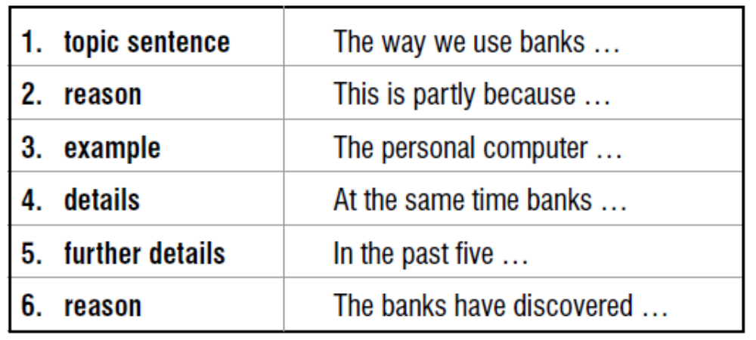

2. A paragraph is a collection of sentences that deal with one subject.
All paragraphs contain a topic sentence, which is often, but not always, the first. Other components vary according to the nature of the topic. Introductory paragraphs often contain definitions, and descriptive paragraphs include a lot of detail. Other sentences give examples and offer reasons and restatements.

3. Read and analyze the following paragraph.
In recent years all British universities have adopted the semester system. A semester is a period of time which lasts for half the academic year. Semester 1, for example, starts in September and finishes in January. Previously the academic year had been divided into three terms: autumn, winter and spring. Most courses consist of modules that last for one semester, and exams are held at the end of each. Britain began using semesters to make it easier for international students to move from one country to another.

1
2
3
4
5
6

4. The sentences below make up a paragraph, but have been mixed up. Use the table to re-write the sentences in the correct order.
a) For many centuries it has been the center of the country’s economic, cultural and social life.
b) 500 years ago it had become a major river port for ships trading with Europe.
c) Its dominance is due to its strategic site near the lowest crossing point of the River Thames.
d) London has been the English capital for over 1000 years.
Topic
Restatement
Reason
Detail

5. The sentences below form a paragraph, but they have been mixed up. Rewrite them in the box overleaf in the correct order and analyze the paragraph structure.
a) This was because of problems with the roof design.
b) Mark Roberts will watch a display of jazz dance and disco.
c) The opening has been delayed by almost three months.
d) The new Leisure Centre will be opened on May 15th by the Sports Minister.
e) The architects are currently being sued for £2 m. by the local council.
1
2
3
4
5

6. You are writing an essay on ‘Prisons make criminals worse, and should be abolished’. Using the notes below, complete the introductory paragraph, following the structure provided.

Introduction
Modern prison system developed in 19th century
Prisons intended to isolate, punish and reform
Steep rise in number of prisoners in last 20 years
Critics claim they are ‘university of crime’
Essay aims to consider how effective prisons are
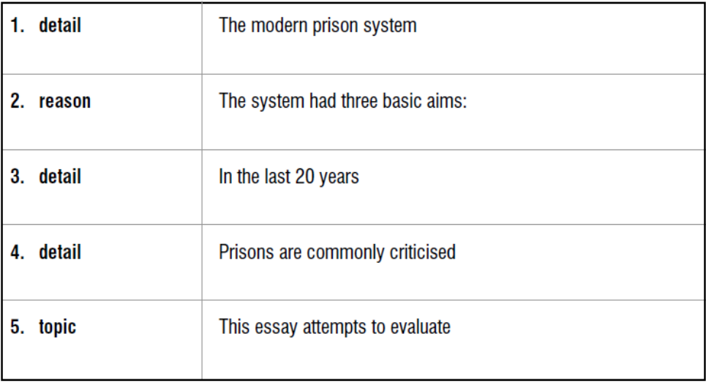

7. Using the second set of notes, write the next paragraph of the essay.
Advantages
prisons offer society three apparent benefits
provide punishment by deprivation of freedom
offenders are segregated so cannot re-offend
possibility of reform through training programs
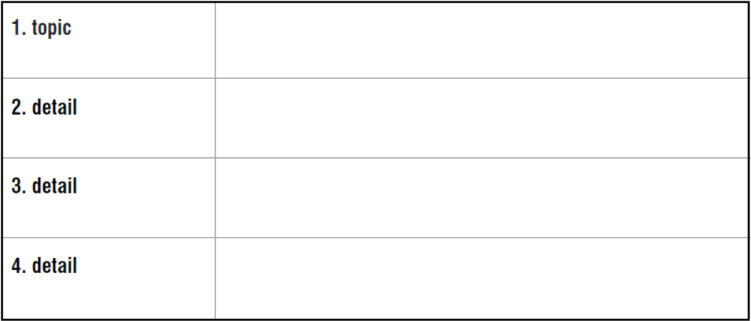

Organizing the Main Body:
1. The structure of the main body depends on the length of the essay and the subject of study.
Longer essays may include the following sections:
Experimental set-up – a technical description of the organization of an experiment
Methods – how the research was carried out
Findings/results – what was discovered by the research/experiment
Case study – a description of an example of the topic being researched
Discussion – an examination of the issues and the writer’s verdict

2. The sections below comprise the main body of an essay titled ‘Studying abroad: an analysis of costs and benefits’. Decide on the heading of each section and the best order for them.
a) Comparisons of the advantages and disadvantages that students mentioned about study abroad and an attempt to decide if most students benefited from the experience.
b) Detailed description of the survey carried out by the researcher.
c) An extensive study of two students (from different cultures) studying in Britain who were interviewed by the researcher.
- A report of what the survey found, with statistical analysis.

3. Inside the main body, ideas need to be presented in the most logical fashion, linked together to form a coherent argument.
Re-organize the notes below to achieve the best structure.

a) Trace the development of the factory system and evaluate its social impact. workers forced to adopt a regular timetable to maintain production first factories employed unskilled workers; often women and children early employers enforced strict codes of discipline factories originally sited to make use of water power (in 18th C.) later some employers offered social benefits, e.g. housing/education in nineteenth century factories built near canals/railways for access to markets

b) Lowering the minimum school leaving age to 14 would allow teachers to focus on teaching the students who wanted to be in school – Discuss. if they left at 14, students would be unlikely to find proper jobs some students more suited to work that doesn’t require qualifications problem students waste everybody’s time, including their own effort should be made in primary schools to prevent pupils falling behind many older students have lost interest in learning and disrupt classes in future, almost all jobs will demand academic skills.

5. It is useful to mark the beginning of new paragraphs or the introduction of new subjects with special phrases.

To introduce a new paragraph/topic:
The main/chief factor/issue is ...
Turning to the subject of …
Moving on to the question of …
Another important area is ...
………… must also be examined

To add information inside a paragraph:
a) Firstly, ... The first point ... In the first place ...
b) Secondly, ... Next, .... Then, ... In addition …
Moreover …
- Finally, ... Lastly,...
6.Complete with suitable phrases the following extract from an essay on ‘British weather’.

The British are famous all over the world for their obsession with the weather, but in fact the reality is more complex than people often believe. This essay sets out to examine some of the principal influences on the weather of the British Isles.
............................................................................ is the geographical position of Britain, situated on the extreme western edge of the European continent. This means that a variety of weather types can dominate the country. ................................... the Atlantic Ocean can produce warm wet winds, especially in winter. .............................. the land mass of Europe can create anti-cyclonic weather, hot in summer and cold in winter. .................. the polar region to the north can generate cold winds at most seasons of the year.

...................................................................... variations within Britain, there are significant differences between regions. ............................... the south of England can be much warmer than the north of Scotland, especially in winter. ........................ the west of Britain is usually much wetter than the east. ........................... even in the same district, hilly areas will be cooler and wetter than the lowlands.

............................................ is seasonal change, which in Britain is less distinct than in many countries. ....................... the Atlantic moderates extreme types of weather, and ....................... the weather pattern can change radically from year to year. As a result warm days in winter and chilly summer winds frequently surprise visitors to this country.

Class & Lab Task, Week 10:
Introductions:
1. What is the purpose of the introduction to an essay? Choose from the items below:
a) to define some of the terms in the title
b) to give your opinion of the subject
c) to show that you have read some research on the subject
d) to show that the subject is worth writing about
e) to explain which areas of the subject you will deal with
f) to get the reader’s attention with a provocative idea
g) to show how you intend to organize your essay

2. It may be necessary to clarify some of the words in the title.
This is to make it clear that you understand the title.
Discuss the impact of privatization on the Pakistan’s economy.
Privatization is the process of transferring certain industries from state control to the private sector, which began in Pakistan in 2010 with Pakistan KESC…

3. In longer assignments it is important to show that you are familiar with current research.
This can be demonstrated using phrases such as:
A number of researchers have examined this issue, notably ...
Various investigations have explored the subject, especially ...

4. You must show the importance of the topic.
This can be either in the academic world or as a contemporary issue of wider relevance. As privatization is increasingly seen as a remedy for economic ills in many other countries, it is worth examining its impact in Pakistan, which was a pioneer in this process.

5. As you are writing only an essay, not a book, it is obviously not possible to deal with all aspects of your subject.
Therefore you need to explain what limits you are setting on the discussion, and possibly give reasons for this. Only privatizations completed between 1981 and 1992 will be dealt with, as it is too soon to assess the impact of later developments.

6. For your own benefit, as well as the reader’s, it is useful to outline how the essay will be organized.
An assessment will first be made of the performance of the privatized industries themselves, on an individual basis, and then the performance of the economy as a whole will be examined.

7. Study the following extracts from introductions below and decide which of the functions in the box they fulfil.
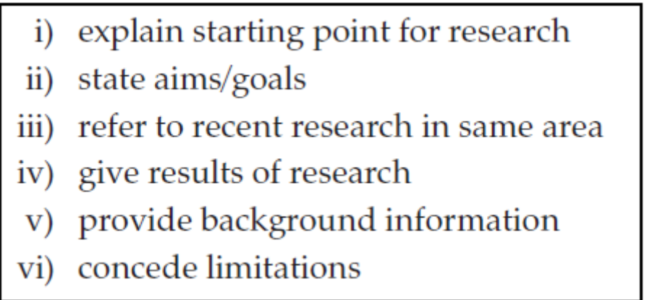
a) In many companies, the knowledge of most employees remains untapped for solving problems and generating new ideas.
b) This paper positions Call Centers at the core of the mix of technologies public administration can use to innovate e-commerce.
c) In fact, this is one of our main findings based on an extended sample period up to 1998.
d) Admittedly, the tenor of my argument is tentative and exploratory.
e) The purpose of this paper is to investigate changes in the incidence of extreme warm and cold temperatures over the globe since 1870.
f) To what extent do increases in the food available per person at a national level contribute to reductions in child malnutrition? This question has generated a wide range of responses (Haddad et al., 1997).

8. There is no such thing as a standard introduction, and much depends on the nature of the research and the length of the essay.
However, for a relatively short essay written under exam conditions the following are worth including, in this order.

a) Definitions of any terms in the title that are unclear
b) Some background information
c) Reference to other writers who have discussed this topic
d) Your purpose in writing and the importance of the subject
e) The points you are going to make/areas you are going to cover

9. Prepare to write an introduction to an essay with the title ‘Higher education should be available to everyone – Discuss’ by answering the questions below.
a) Which terms in the title might need defining?
b) What background information could you give?
c) How can you show the relevance of this topic, in either Britain or another country?
d) How are you going to limit your discussion, geographically, historically or both?
- How will you organize the main body of the essay?
11. Write an introduction to an essay on one of the following subjects, or choose a subject from your own discipline.
a) Compare the urbanization process in the First and the Third Worlds.
b) Assess the importance of public transport in the modern city.
c) ‘Lawyers are inflating the cost of medicine’ – Discuss.
d) To what extent is a democratic system necessary for economic development?

Conclusions:
1. Not every academic essay has a conclusion.
In some cases it may be linked to the discussion section, or it may be called concluding remarks, or summary. However, in most cases it is helpful for the reader to have a section that (quite briefly) looks back at what has been said and makes some comments about the main part.

Read the following extracts from conclusions and match them with the list of functions in the box.
- In this review, attempts have been made to summarize and assess the current research trends of transgenic rice dealing exclusively with ergonomically important genes.

- As always, this investigation has a number of limitations to be considered in evaluating its findings.

- Obviously, business expatriates could benefit from being informed that problem-focused coping strategies are more effective than symptom focused ones.

- Another line of research worth pursuing further is to study the importance of language for expatriate assignments.

- Our review of 13 studies of strikes in public transport demonstrates that the effect of a strike on public transport ridership varies and may either be temporary or permanent.

- These results of the Colombia study reported here are consistent with other similar studies conducted in other countries (Baron & Norman, 1992).

- To be more precise, there was a positive relation between tolerant and patient problem solving and all four measures of adjustment: general, interaction, work and subjective well-being.

- To empirically test this conjecture, we need more cross-national replication of this research.

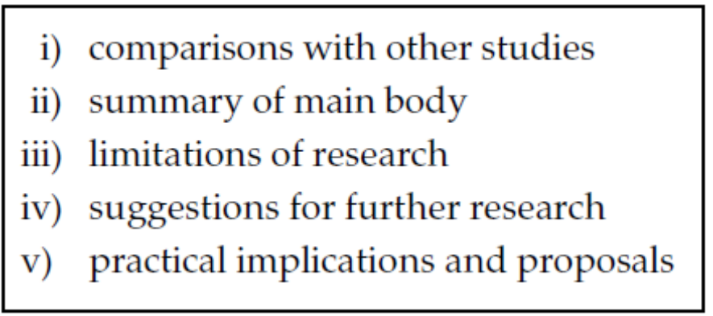

- Compare the following conclusions to two essays on ‘Public transport in a modern economy’. Complete the table to show the main differences between them.
a) As has been shown, public transport is likely to play an important role in the future. Despite possible changes in patterns of work and leisure, it seems possible that mass transport systems will remain necessary for the efficient movement of people. What is not clear is how such transport systems should be funded. Various schemes have been discussed, but the most effective model will probably contain some element of public funding. Market forces alone are unlikely to provide a satisfactory solution.
b) In such a brief study it is hard to draw definite conclusions about the future shape of public transport. The main areas of debate have been outlined, but much more research is needed before firm recommendations can be made. It can be seen that this is a controversial area, with strong protagonists on either side. Whether public transport flourishes or deteriorates in future is still unclear, though further studies may eventually suggest an answer.
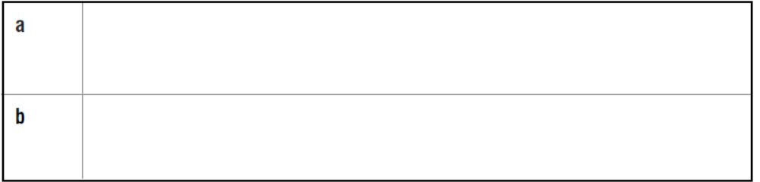
3. The following may be found in conclusions. Decide on the most suitable order for them (A–E).
Implications of the findings
Proposals for further research
Limitations of the research
Reference to how these findings compare with other studies
Summary of main findings
Below are notes for the main body of an essay. Read the notes and complete the conclusion, using your own ideas if necessary.

Cultural adaptation among overseas students at a British university.
a) The research programme
purpose: to study how students from different cultural backgrounds adapt to academic life in the UK
size and method: 250 questionnaires returned (30% Chinese, 25% SE Asian, 20% Middle Eastern, 25% other)
b) Findings – culture was only one factor in determining successful adaptation. Other important factors: age/previous experience of living abroad/language proficiency
c) Discussion – how accurate was research? How could it have been improved? What can be done to help students adapt better?

summary | The aim of the study was to explore differing degrees of adjustment to life at a British university among overseas students from a variety of cultural backgrounds. 250 valid questionnaires were completed,  representing about a third of the overseas student population, with  significant numbers of Chinese, SE Asian and Middle Eastern students. The results suggest …………
implications
limitations
proposals for further research

Proof-Reading:
1. Before handing in any piece of written work for marking, it is important to check it carefully for errors that may distort your meaning or even make your work difficult to understand.
The following examples each contain one common type of error. Underline the error and match it to the list of error types in the box.
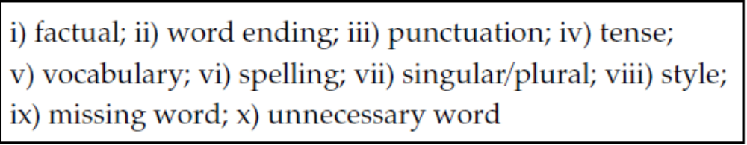
a) The natural poorness of Japan has been overcome …
b) In 1980 in the United States there are 140,000 people who …
c) Actually, hardly any of these has succeeded …
d) … to choose the most suitable area in which they can success.
e) Chinese history reflects in real social and cultural changes.
f) The highest rate of imprisonment was registered in the USA …
g) Malaria is on the increase in countries such as Africa …
h) I am very interested in German economy …
i) … the French system is quite different.
j) You don’t always know which method is best.

- When proof-reading, it is a good idea to exchange texts with another student, since you may become over-familiar with your own work.

However, even in exam conditions, when this is not possible, it is vital to spend a few minutes checking through your work, for this may reveal careless errors that can be quickly corrected.

Underline and correct the errors in the extracts below (one or two in each).
a) The graph shows changes in the number of prisoners over five years (1930–1980).
b) … the way the government prepares his citizens to contribute in the development ...
c) Secondly, education not only teach people many knowledge …
d) However, weather it is the most important factor is the issue …
e) There has been a sharp decrease between 1930 and 1950.
f) The quality of a society depends in the education level.
g) America had the biggest figure for crime.

Class & Lab Task, Week 12:
Cause and Effect:
1. The relationship between two situations can be shown in a variety of ways:
Heavy rain causes flooding.
Heavy rain leads to flooding.
Heavy rain results in flooding.
Heavy rain produces flooding.
Flooding is caused by heavy rain (note use of passive).
Flooding is produced by heavy rain.
Flooding results from heavy rain.
2. It is also possible to use conjunctions that demonstrate cause and effect.
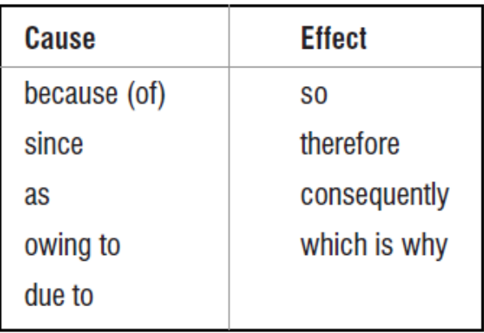
Because it rained heavily, the flooding was severe. (because + verb) The flooding occurred because of days of heavy rain. (because + noun) Owing to the heavy rain the flooding was severe.
It rained heavily for days, therefore the flooding was severe. (used in midsentence) NB It is more common to use conjunctions to illustrate particular situations.

- Complete the following sentences with a suitable verb or conjunction.

a) Childhood vaccination . . . . . . . . . . . . . . . . . . . . . . . . reduced infant mortality.
b) . . . . . . . . . . . . . . . . . . . . . . . . . . . . . . . . the cold winter hospital admissions increased.
c) Printing money . . . . . . . . . . . . . . . . . . . . . . . . . . . . . . . . higher inflation.
d) The summer was extremely dry, . . . . . . . . . . . . . . . . . . . . . . . . . . . . . . . many trees died.
e) Increased ownership of video recorders . . . . . . . . . . . . . . . . . . . . . . falling cinema attendance.

- Write three more sentences from your own subject area.

f) ___________________________________________________________________________
g) ___________________________________________________________________________
h) ___________________________________________________________________________
4. Use conjunctions to complete the following paragraph.

WHY WOMEN LIVE LONGER

Some British scientists now believe that women live longer than men a) . . . . . . . . . . . . . . . T cells, a vital part of the immune system that protects the body from diseases. Previously, various theories have attempted to explain longer female life expectancy. Biologists claimed that women lived longer b) . . . . . . . . . . . . . . . . . . . . . they need to bring up children. Others argued that men take more risks, c) . . . . . . . . . . . . . . . . . . . . . they die earlier. But a team from Imperial College think that the difference may be d) . . . . . . . . . . . . . . . . . . . . . women having better immune systems. Having studied a group of men and women they found that the body produces fewer T cells as it gets older, e) . . . . . . . . . . . . . . . . . . . . . the ageing process. However, they admit that this may not be the only factor, and f) . . . . . . . . . . . . . . . . . . . . . another research project may be conducted.

Study the flowchart and complete the paragraph that describes it.

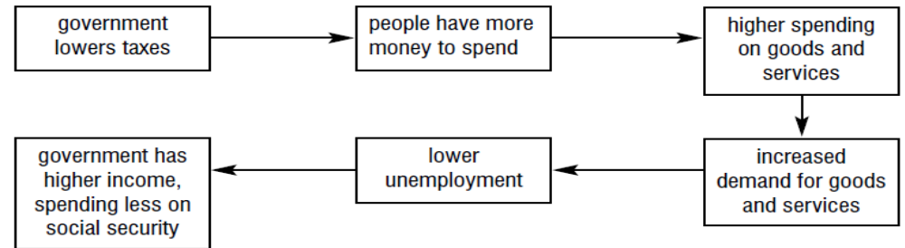
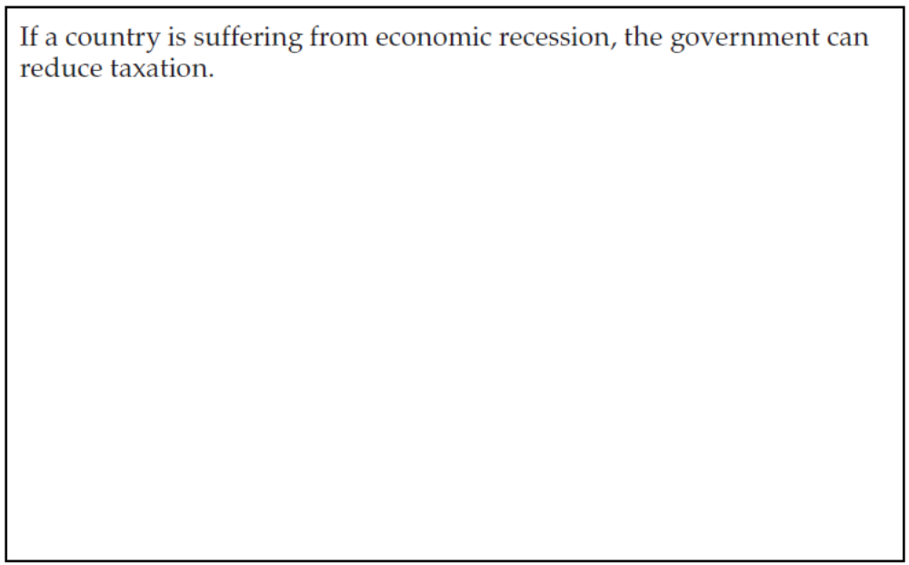

Cohesion:
1. Cohesion means linking phrases together so that the whole text is clear and readable.
It is achieved by several methods, such as the use of conjunctions.
Another is the linking of phrases and sentences with words like he, they and that which refer back to something mentioned before:
Jane Austen wrote six major novels in her short life. They deal with
domestic drama in middle-class families.

Examples of reference words and phrases
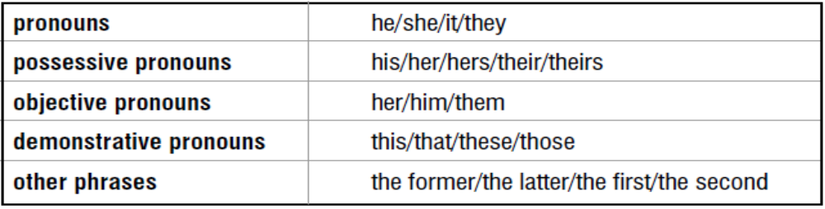
2. Read the following paragraph and complete the table.
Jenkins (1987) has researched the life cycle of new businesses. He found that they have an average life of only 4.7 years. This is due to two main reasons; one economic and one social. The former appears to be a lack of capital, the latter a failure to carry out sufficient market research. Jenkins considers that together these account for approximately 70% of business failures.

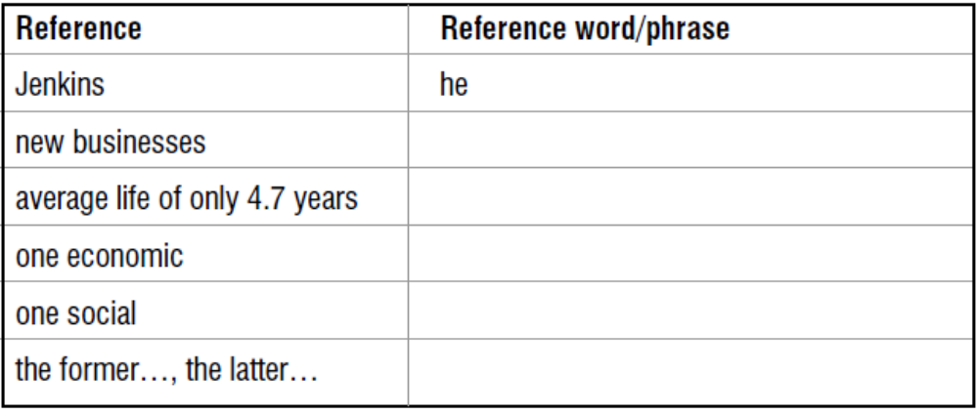
4. In the following paragraph, insert suitable reference words from the box below in the gaps.
Disposable razor blades were invented by Gillette at the beginning of the twentieth century.
a) . . . . . . . were a simple idea but at first
b) . . . . . . . found it very hard to sell
c) . . . . . . . . .
d) . . . . . . . was because nobody had marketed a throw-away product before. However,
e) . . . . . . . use of advertising to stimulate demand gradually increased sales and before long
f) . . . . . . . became a millionaire.

Comparisons:
1. The two basic comparative forms are:
The Pacific Ocean is larger than the Atlantic.
His work is more interesting than hers.
a) -er is added to one-syllable adjectives (slow/slower) and two-syllable adjectives ending in –y (easy/easier).
b) more . . . . . . . . . . . . . . is used with words of two or more syllables: careful/more careful
quickly/more quickly.
However, there are some two-syllable words that can use either form: simple/simpler/more simple.
2. Comparisons can be made more exact by using slightly, considerably or significantly before the comparative:
Dickens’s novels are considerably longer than Austen’s.
The new Mercedes is slightly more economical than the old model.
3. Study the table and complete the exercise below.
Cost of sending a letter to a domestic destination (eurocent)
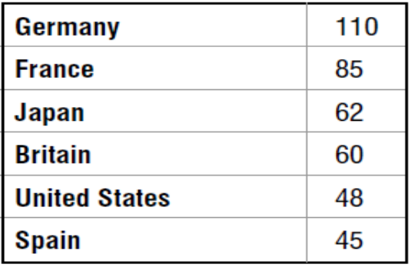
a) Letters in France are . . . . . . . . . . . . . . . . . . . . . . . . . . . . . . . . . . . . . . . . . . . . . . . . . . . . . . . . . . . . . in Japan.
b) Spanish letters are . . . . . . . . . . . . . . . . . . . . . . . . . . . . . . . . . . . . . . . . . . . . . . . . . . . . . German letters.
c) American letters are. . . . . . . . . . . . . . . . . . . . . . . . . . . . . . . . . . . . . . . . . . . . . . . . . . letters in Britain.
d) Letters in Germany are. . . . . . . . . . . . . . . . . . . . . . . . . . . . . . . . . . . . . . . . . . . . . . . . . . . . . in America.
4. The form as . . . . . . . . . . . . as can be used to stress similarity:
British letters are nearly as expensive as Japanese letters.
It can also be used for quantitative comparison:
German letters are twice as expensive as American letters
Also: half as/three times as/etc.
5. Note the variety of forms possible:
German letters are more expensive than French (ones/letters). (least formal)
Letters in Germany are more expensive than (those) in France.
The cost of sending a letter is higher in Germany than in France. (most formal)
NB. high and low are used for comparing abstract concepts such as rates.
Ones can replace the noun when used with an adjective:
German letters are more expensive than Japanese ones.
But not in combination with a noun:
Family cars are cheaper than sports cars. (not sports ones)
6. More/less, the most/the least (followed by adjective), the most/the fewest (related to number)
Divorce is less common in Greece than in Britain.
The most crowded country in Europe is Holland.
The School of Education offers the most modules. (more than others)
7. Complete the following description of the table in (3) above (one word per gap):
According to the table, Spain is the a) . . . . . . . . . . . . . . . . expensive country for sending a domestic letter. The USA is b) . . . . . . . . . . . . . . . . more expensive, while the cost in Britain is c) . . . . . . . . . . . . . . . . the same d) . . . . . . . . . . . . . . . . in Japan. France and Germany are the e) . . . . . . . . . . . . . . . . expensive countries; France being 20% cheaper f) . . . . . . . . . . . . . . . . Germany. Overall, posting a letter costs g) . . . . . . . . . . . . . . . . as much in Spain h). . . . . . . . . . . . . . . . in Germany.

Class & Lab Task, Week 13:
Definitions:
1. In academic writing, definitions are normally needed in two situations:
a) In introductions, to clarify a word or phrase in the title.
b) More generally, to explain a word or phrase that may be either very technical (and so not in normal dictionaries), or very recent, or with no widely agreed meaning.
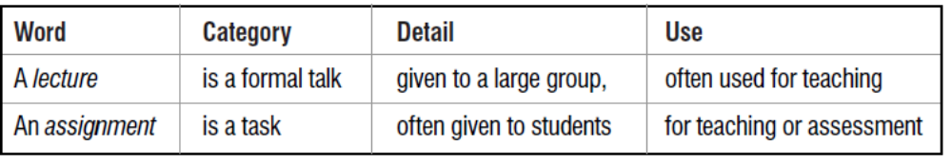

2. Insert suitable category words in the following definitions.
a) A barometer is a scientific . . . . . . . . . . . . . . . designed to measure atmospheric pressure.
b) Kidneys are . . . . . . . . . . . . . . . that separate waste fluid from the blood.
c) A multi-national company is a business . . . . . . . . . . . . . . . that operates in many countries.
d) Reinforced concrete is a building . . . . . . . . . . . . . . . consisting of cement, sand and steel rods.
e) Bullying is a pattern of anti-social . . . . . . . . . . . . . . . found in many schools.
f) Recycling is a . . . . . . . . . . . . . . . in which materials are used again.
g) A recession is a . . . . . . . . . . . . . . . of reduced economic activity.
h) Postcodes are a . . . . . . . . . . . . . . . for making mail delivery more efficient.
3. More complete definitions may be written by adding examples or extra information:
A mortgage is a type of loan (that is) used for buying property, in which the lender has the security of the property.
Complete and extend the following definitions.
a) Distillation is a . . . . . . . . . . . . . . . . . . . . . used to . . . . . . . . . . . . . . . . . . . . . . . . . . . . . . . . . . . .
b) A psychiatrist is a . . . . . . . . . . . . . . . . . . . . . who specializes in . . . . . . . . . . . . . . . . . . . . . . . . .
c) An MSc. is a . . . . . . . . . . . . . . . . . . . . . awarded on completion of . . . . . . . . . . . . . . . . . . . . . . .
d) A trades union is a(n). . . . . . . . . . . . . . . . . . . . . that exists to protect. . . . . . . . . . . . . . . . . . . . . .
e) Malaria is a . . . . . . . . . . . . . . . . . . . . . . . . . . . . . . . . . . . caused by. . . . . . . . . . . . . . . . . . . . . . .
f) Wheat is a . . . . . . . . . . . . . . . used for . . . . . . . . . . . . . . . . . . . . . . . . . . . . . . . . . . . . . . . . . . . . . .
4. Study the following examples and underline the term being defined.
a) … the definition for a failed project … ranges from abandoned projects to projects that simply do not meet their full potential or simply have schedule overrun problems.
b) Development is a socio-economic–technological process having the main objective of raising the standards of living of the people. reference
c) Electronic commerce is characterized by an absence of physical proximity between the buyer and seller in conducting the search, assessment and transaction stages of a transaction.
d) Bowlby (1982) suggested that attachment is an organized system whose goal is to make individuals feel safe and secure.
e) … the non-linear effect called ‘self-brightening’ in which large-amplitude waves decay more slowly than small-amplitude ones.

The examples above illustrate the variety of methods employed in definitions:
(a) gives various examples that fall into the grouping the author wishes to examine.
(b), (d) and (e) use category words: process, system, effect.
(c) defines the term in a negative way (an absence).
(d) quotes a definition from another writer.
Discussion:
1. Many essay titles require the writer to examine both sides of a case and to conclude by coming down in favor of one side.
These may be called discussion, for and against or argument essays. For example:
a) School uniforms – a step forward or a step back? – Discuss.
b) Discuss the advantages and disadvantages of state control of industry.
Discussion vocabulary
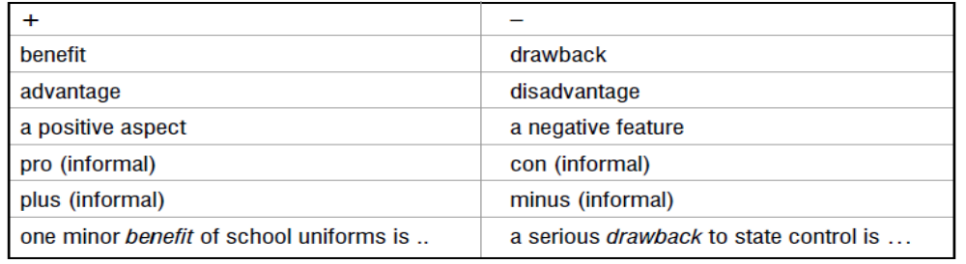
2. There are two basic outlines for a discussion essay:
i) School uniforms?
a) advantages: reduce social inequality/encourage group identity/avoid choice
b) disadvantages: loss of individuality/expense/unfashionable
c) discussion: overall, benefits more valuable in most cases
ii) School uniforms?
a) social: emphasizes group values – diminishes individual choice
b) practical: expensive for poor families but easier to get dressed
c) discussion: overall, benefits more valuable in most cases

3. Choose one of the titles below and write down as many pros and cons in the box as possible. Then prepare a plan using one of the outlines above.
a) Instead of going out to work, mothers should stay at home and look after their children until they are at least five – Discuss.
b) Fast food, which is spreading round the world and destroying national cultures, should be resisted. To what extent do you agree?

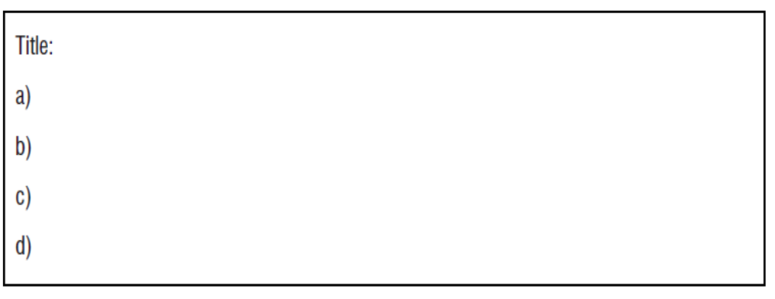
4. Presenting your case.
It is better to use impersonal phrases rather than I think:
It is widely believed that young children need to be with their mothers …
Most people consider that fast food is very convenient …
It is generally agreed that school uniforms develop a group identity …
It is probable/possible that fast food will become more acceptable …
This evidence suggests that most children benefit from nurseries …
However, if you want to defend a minority point of view, you can use the following:
It can be argued that children benefit from a diet of hamburgers.
It has been suggested that school uniforms make children more rebellious.
Some people believe that nursery education damages children.

It is important to show that you are aware of counter-arguments, which can be presented first. Study the example and write similar sentences about working mothers and fast food using ideas from (3).
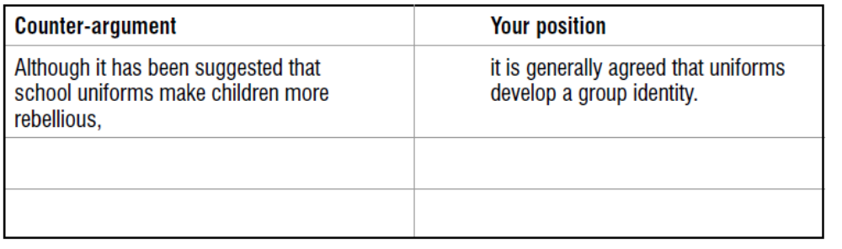
5. Before giving your own opinion, it is necessary to show that you have read the relevant sources and have studied the evidence.
Opinions without evidence have little value. The following paragraph discusses the environmental effects of deforestation.
Lomborg (2001) claims that the danger of extinction of species has been exaggerated. He says that the number of species had been expected to decline dramatically within the next half century, but maintains that this is unlikely: ‘Species … seem more resilient than expected.’ He points out that in the eastern USA, although 98% of the original forests have been cleared, only one forest bird became extinct in the process. Against this, Brooks (2001) feels that Lomborg is ignoring the true rate of forest loss and the related extinction of species: ‘The ongoing wave of extinctions, due primarily to deforestation in the moist tropics, has been widely documented.’ It seems that Lomborg, as a statistician, is too dependent on optimistic data, and is ignoring the widespread concerns of wildlife experts.

The paragraph has the following structure:
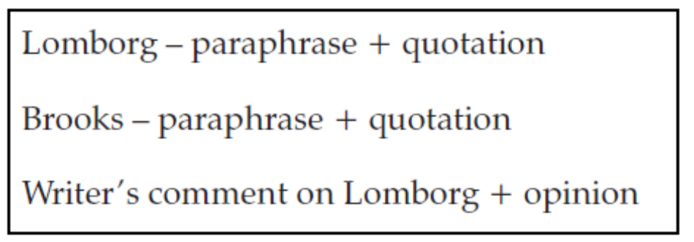
6. Complete the following paragraph, which discusses air pollution, to give an opinion.
According to Lomborg (2001), air quality is improving in rich countries. He gives the example of
London, where he claims that the air is cleaner now than it has been since 1585, thanks to decreases in smoke and sulphur dioxide. Brooks (2001), however, argues that Lomborg is ‘ignoring the more recent global rise in toxic contaminants, now found at high concentrations … even in the remote reaches of the Arctic.’ It appears that . . . . . . . . . . . . . . . . . . . . . . . . . . . . . . . . . . . . . . . . . . . . . . . . . . . . . . . . . . . . . . . . . . . . . . . . . . . . . . . . . . . . . . . . . . . . . . . . . . . . . . . . . . . . . . . . . . . . . . . . . . . . . . . . . . . . . . . . . . . . . . . . . . . . . . . . . . . . . . . . . . . . . . . . . . . . . . . . . . . . . . . . . . . . . . . . . . . . . . . . . . . . . . . . . . . . . . . . . . . . . . . . . . . . . . . . . . . . . . . . . . . . . . . . . . . . . . . . . . . . . . . . . . . . . . . . . . . . . . . . . . . . . . . . . . . . . . . . . . . . . . . . . . . . . . . . . . . . . . . . . . . . . . . . . . . . . . . . . . . . . . . . . . . . . . . . . . . . . . . . 7. List in the box as many ideas as possible for and against the following subject:
‘Civilization began in the city, and the city remains the only place for civilized people to live’ –
Discuss.

8. Prepare a plan for this title, using one of the outlines in (2) above.
a)
b)
c)
d)
9. Write an essay on this title, making use of phrases from (4) above.
Class & Lab Task, Week 14:
Examples:
1. When writing essays it is often better to support statements by giving examples.
Compare the following:
a) Many plants and animals are threatened by global warming.
b) Many plants and animals are threatened by global warming. In southern Britain, for example, the beech tree may become extinct within 30 years. The second sentence provides concrete details of a plant species, an area and a time scale to support the main statement.

2. Phrases for introducing examples include:
Many departments, for instance/for example engineering, now offer foundation courses. (note use of commas)
A few courses such as/e.g. MBA require work experience.
Many universities, particularly/especially UK ones, ask overseas students for IELTS scores. (note the focus)
Some subjects are heavily oversubscribed. A case in point is medicine. (for single examples)

Use suitable example phrases to complete the following sentences.
a) As the climate warms, wetland species . . . . . . . . . . . . . . . . . frogs may find their habitat reduced.
b) Some animals can migrate to cooler areas. . . . . . . . . . . . . . . . . . are birds, which can move easily.
c) Many plants, trees . . . . . . . . . . . . . . . . ., will find it difficult to move to wetter regions in the north.
d) Certain reptiles, . . . . . . . . . . . . . . . . . snakes, may benefit from drier and warmer summers.
e) Rising sea levels may bring some advantages . . . . . . . . . . . . . . . . . expanding wetland areas.

3. Find a suitable example for each sentence.
Example:
Various sectors in the economy are experiencing labor shortages. Various sectors in the economy, for instance engineering, are experiencing labor shortages.
a) A number of sports have become very profitable due to the sale of television rights.
b) Some British universities offer special courses in English for overseas students.
c) In recent years many women have made significant contributions to the political world.
d) Three-year guarantees are now being offered by most car makers.
e) Certain diseases are proving much harder to combat than was expected 20 years ago.
f) Many musical instruments use strings to make music.
g) Several mammals are currently in danger of extinction.

4. Provide examples in the following paragraph where they appear necessary.
Students who go to study abroad often experience a type of culture shock when they arrive in the new country. Customs which they took for granted in their own society are not followed in the host country. Even everyday patterns of life may be different. When these are added to the inevitable differences which occur in every country students may at first feel confused. They may experience rapid changes of mood, or even want to return home. However, most soon make new friends and, in a relatively short period, are able to adjust to their new environment. They may even find that they prefer some aspects of their new surroundings, and forget that they are not at home for a while!

Generalizations:
1. Decide if you agree with the following:
a) When two Englishmen meet, their first talk is of the weather. (Samuel Johnson)
b) A bank is a place that will lend you money if you can prove that you don’t need it. (Bob Hope)
The above are well-known quotations, which are remembered because they are funny, though only partly true. This shows that generalizations are easy to remember, if not always accurate.

2. In written work generalizations are very useful because they can be used to present complex ideas or data in a simple form:
Large companies can offer better career opportunities.
Language is an important means of communication.
Study the table below and compare the statements.

UK smokers by gender
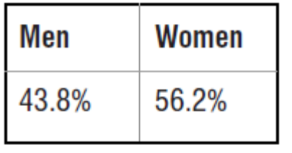
a) 56.2 % of British smokers are women.
b) The majority of British smokers are women.
The first sentence is more accurate, but the second, which contains a generalization, is easier to understand. However, using generalizations does involve a loss of precision, so the writer must judge when they can be used safely, and when it is better to give the full data.

3. There are two ways of making a generalization:
a) Using the plural: Computers are useful machines.
b) Using definite article and the singular: The computer is a useful machine. (less common/more formal)
It is better to avoid absolute phrases such as cats are cleverer than dogs.
Instead use more cautious phrases such as cats tend to be cleverer than dogs or most cats are more intelligent than dogs.

Write generalizations on the following topics.
a) child/noise Example: Children are often noisy.
b) flowers/presents . . . . . . . . . . . . . . . . . . . . . . . . . . . . . . . . . . . . . . . . . . . . . . . . . . . . . . . . . . . . . . .
c) city/pollution . . . . . . . . . . . . . . . . . . . . . . . . . . . . . . . . . . . . . . . . . . . . . . . . . . . . . . . . . . . . . . . . .
d) fresh fruit/health . . . . . . . . . . . . . . . . . . . . . . . . . . . . . . . . . . . . . . . . . . . . . . . . . . . . . . . . . . . . . . e) television/important . . . . . . . . . . . . . . . . . . . . . . . . . . . . . . . . . . . . . . . . . . . . . . . . . . . . . . . . . . . .
4. Read the following text and underline the generalizations.
Li Pang is a Chinese student studying architecture in Manchester. He enjoys the style of teaching as well as the cosmopolitan lifestyle the city provides. Many international students attend British universities. Most welcome the chance to meet classmates from all over the world, and all are pleased to have the chance to improve their English. When he goes home to Shanghai, Li Pang will have a network of international contacts to support his future career.

7. Read this text about dreams and write five generalizations using the data.
A recent survey on dreams, completed by over 10,000 people, found that 68% of all dreams came into the ‘anxiety’ category. Being chased was the most common dream, recorded by 72%. Dreams about falling (which signify insecurity) are also very common, being recorded by 70%. 55% have dreamed about relatives and friends who have died. Many people believe that dreams can foretell the future, but only 42% have experienced this type. 28% of those surveyed have dreams about food, which seem to occur during periods of weight watching, but 23% have been pleased by dreams of finding money.
Example:
Anxiety seems to be the cause of most dreams.
a) . . . . . . . . . . . . . . . . . . . . . . . . . . . . . . . . . . . . . . . . . . . . . . . . . . . . . . . . . . . . . . . . . . . . . . . . . . . . . . . . . . . . . . . . . . . . . . . . . . . . . . . . .
b) . . . . . . . . . . . . . . . . . . . . . . . . . . . . . . . . . . . . . . . . . . . . . . . . . . . . . . . . . . . . . . . . . . . . . . . . . . . . . . . . . . . . . . . . . . . . . . . . . . . . . . . . . .
c) . . . . . . . . . . . . . . . . . . . . . . . . . . . . . . . . . . . . . . . . . . . . . . . . . . . . . . . . . . . . . . . . . . . . . . . . . . . . . . . . . . . . . . . . . . . . . . . . . . . . . . . . . .
d) . . . . . . . . . . . . . . . . . . . . . . . . . . . . . . . . . . . . . . . . . . . . . . . . . . . . . . . . . . . . . . . . . . . . . . . . . . . . . . . . . . . . . . . . . . . . . . . . . . . . . . . . . .
e) . . . . . . . . . . . . . . . . . . . . . . . . . . . . . . . . . . . . . . . . . . . . . . . . . . . . . . . . . . . . . . . . . . . . . . . . . . . . . . . . . . . . . . . . . . . . . . . . . . . . . . .
Class & Lab Task, Week 15:
Numbers:
1. Discussing statistical data is a necessary part of much academic writing:
Approximately 1800 children between the ages of 5 and 12 years were randomly selected. Already 3% of the US working population (1.55 million) are employed in 70,000 centers … The earth’s atmosphere appears to be gaining 3.3 billion metric tons of carbon annually …… but 5 winters in the 20th century were more than 2.4°C colder than average.

Figures and numbers are both used to talk about statistical data in a general sense.
The figures in the report need to be read critically.

Digits are individual numbers. Both fractions (1⁄2) and decimals (0.975) may be used.
4,539 – a four digit number
£225,000 – a six figure salary (a number)
Figure (Fig) 3 – Infant mortality rates in twelfth-century France (a diagram) no final -s on hundred/thousand/million:
Six million people live in the region.
but: Thousands died in the last outbreak of cholera.

2. When presenting data, the writer must attempt to be accurate without confusing the reader with too much detail.
In some cases, where the actual number is unimportant, words or phrases may replace numbers to simplify the text:
43 villages were cut off by the heavy snowstorm.
Dozens of villages were cut off by the heavy snowstorm.

The following words or phrases can be used to describe quantity.
Few students attended her lecture. (less than expected)
Several bodies have been discovered under the temple floor. (3–4)
Various attempts were made to reach the sunken ship. (3–6)
Dozens of politicians attended the opening ceremony. (30–60)
Scores of books are published every week. (50–100).

Re-write the following sentences using one of the words or phrases above.
a) Only four people responded to the questionnaire.
b) They received nearly 100 applications for the post.
c) She made five or six proposals to improve the team’s performance.
d) He found over 50 factual errors in the article.
e) They made three or four drafts before writing the final report.
3. Percentages are commonly used for expressing rates of change:
Overseas students in the university 1997–2000
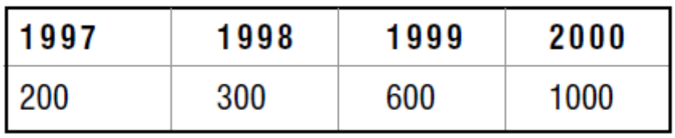
Between 1997 and 1998, the number of overseas students increased by 50%.
The number increased by 100% the following year.
There was a 400% increase between 1997 and 2000.

4. Study the following expressions, which are also used to simplify statistics.
one in three a third/a quarter
twice/three times as many the majority/the minority
a tenfold increase fifty per cent, a percentage
to double/to halve on average/the average number
the most/the least a small/large proportion

Rewrite each sentence in a simpler way, using one of the expressions above.
a) Of the 415 people interviewed, 308 said that they supported the president.
b) Last year the number of students on the course was 28, the year before it was 20 and this year it is 24.
c) In 1965 a liter of petrol cost 10p, while the price is now 80p.
d) Out of 18 students in the group, 12 were women.
e) The new type of train reduced the journey time to Madrid from seven hours to three hours 20 minutes.
f) 15 of the students studied law, eight finance and three engineering.
g) The numbers applying to this department have risen from 350 last year to 525 this year.

References and Quotations:
1. A reference is an acknowledgement that you are making use of another writer’s ideas or data in your writing:
As Donner (1997) pointed out, low inflation does not always lead to low interest rates.
There are three main reasons for giving references:
a) To avoid the charge of plagiarism, which is using another person’s ideas or research without acknowledgement.
b) The reference can give more authority to your writing, for it shows you are familiar with other research on the topic.
c) The reader can find the original source by using the reference section, which would list the full publishing details of Donner’s book:
Donner, F. (1997) Macroeconomics. Borchester: Borchester University Press

2. Decide which of the following need references.
a) A mention of facts or figures from another writer
b) An idea of your own
c) Some data you have found from your own research
d) A theory suggested by another researcher
e) A quotation from a work by any author
f) Something that is agreed to be common knowledge

3. In order to give references accurately it is important to follow the following procedure:
a) When reading and note-making, keep a careful record of the details of your sources. For a long piece of writing such as a dissertation a card index is useful.
b) Find out which system of referencing is used in your subject area. You can do this by studying current textbooks and journals and checking departmental guidelines.
c) Follow one of the methods illustrated below to give the reference.

4. a) Summary of a writer’s ideas.
Orwell (1940) pointed out that although Charles Dickens described eating large meals in many of his books, he never wrote about farming. He explains this contradiction in terms of Dickens’ upbringing in London, remote from the countryside.

b) Quotation of a writer’s words.
Orwell clearly highlighted this inconsistency in Dickens: ‘It is not merely a coincidence that Dickens never writes about agriculture and writes endlessly about food. He was a Cockney, and London is the center of the earth in rather the same sense that the belly is the center of the body.’ (Orwell, 1940: pp. 53-54)

c) Mixture of summary and quotation.
As Orwell (1940) noted, Dickens frequently described food but was uninterested in food production. He considered that this was because of the writer’s background: ‘He was a Cockney, and London is the center of the earth.’(pp.53–54)

5. Read the following extract from the same essay (‘Charles Dickens’ in Inside the Whale, Orwell, G., 1940: pp.54–55)
What he does not noticeably write about, however, is work. In Dickens’ novels anything in the nature of work happens off-stage. The only one of his heroes who has a plausible profession is David Copperfield, who is first a shorthand writer and then a novelist, like Dickens himself. With
most of the others, the way they earn their living is very much in the background.

a) Write a summary of the author’s ideas, including a suitable reference.
b) Introduce a quotation of the key part of the extract, again referring to the source.
Combine (a) and (b), again acknowledging the source.

6. Referring verbs use both the present and the past tenses.
It is probably best to use the present tense for recent sources or when you feel that the ideas or data are still valid:
Rathbone (1997) demonstrates the limitations of video-conferencing.
The past tense suggests that the source is older and the ideas perhaps outof-date:
Steinbeck (1965) explored a link between cancer and diet.
7. There are three main systems of reference in use in academic writing:
a) The system illustrated above (the Harvard) is the most common. Note the following:

Hunter (1989) states … (date of publication in brackets when referring verb is used) Women pose less security risk. (Burke and Pollock, 1993) (authors and date in brackets after summary)

NB. For quotations page numbers should also be given after the date.
Details of the organization of the reference section are given in (8) below.

b) Numbers in brackets are inserted in the text for each source, and at the end of the chapter or article the references are listed in number order:
A survey of Fortune 500 companies found that over 70% have problems recruiting skilled staff (1). Some analysts argue that this could be as high as 90% (2).
1. Cuervo, D. 1990, Whither Recruitment? HR Journal 13. pp. 23–39.
2. Segall, N. 1996, Cross-cultural studies, Harper & Row, New York pp. 173-4.
c) A third system uses footnotes:
More than 80% of families own or are buying their own homes.2 In this system the references are listed at the bottom of the page:
- The Economist, 13 January 1996, pp. 27–8.
NB. A full reference section is required at the end of the article or book.

8. Organizing the bibliography/references
Here is the reference section of an essay written by a business student.
Study the pattern of organization and answer the following questions.
a) How are the entries ordered?
b) What is the difference between the information provided for:
i) a book by one author
ii) an edited book
iii) a source on the internet
iv) an article in a journal
c) When are italics used?
d) How are capital letters used in titles?
e) How is a source with no given author listed?

REFERENCES
1. Brzeski, W. (1999) The Polish Housing Market www.onenet.pl (Access date 15 Feb.
2000).
2. Hill, S. (1989) Managerial Economics, The Analysis of Business Decisions. London:
Macmillan Education Ltd. pp. 100–135.
3. Koutsoyiannis, A.P. (1963) ‘Demand function for tobacco’ in Wagner, L. (ed) Readings
in Applied Microeconomics. Oxford: Oxford University Press.
4. Mintel Database (2000), Retail Coffee Market in the UK (31 Jan. 2000) Available via
Warwick University Library (Access date 20 Feb. 2000).
5. Pass, C. and Lowes, B. (1997) Business and Microeconomics. London: Routledge pp.
16-40.
6. Peck, S. (2000) Managerial Economics Course Notes. Warwick Business School.
7. Russell, T. (1995) ‘A future for coffee?’ Journal of Applied Marketing 6 pp. 14–17.

Essay Writing Topics:

- Compare the benefits of eating fast food to those of eating home-cooked meals. Select three points of comparison & contrast.
- Describe a sad (or happy) day in your life or the day you decided to change your life.
- Explain how to enjoy the weekend for under Rs.200/-
- What are the effects of social networking sites?
- What are advantages and disadvantages of living on campus and living off campus?
- Classify various methods of saving money.
- What are the different ways of protecting the environment?
- What are the effects of illiteracy?
- What are causes & effects of child neglect?
- Define & explain racism and prejudice.

